Code 1
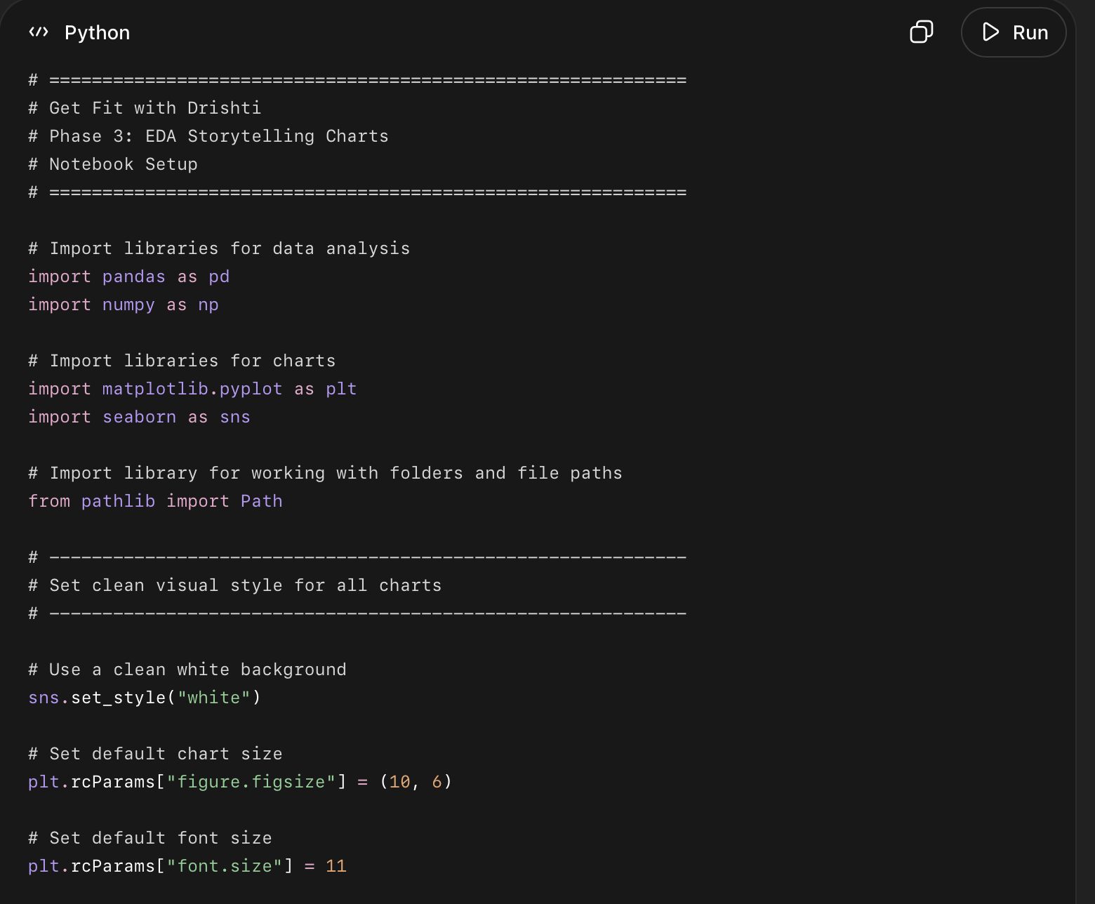
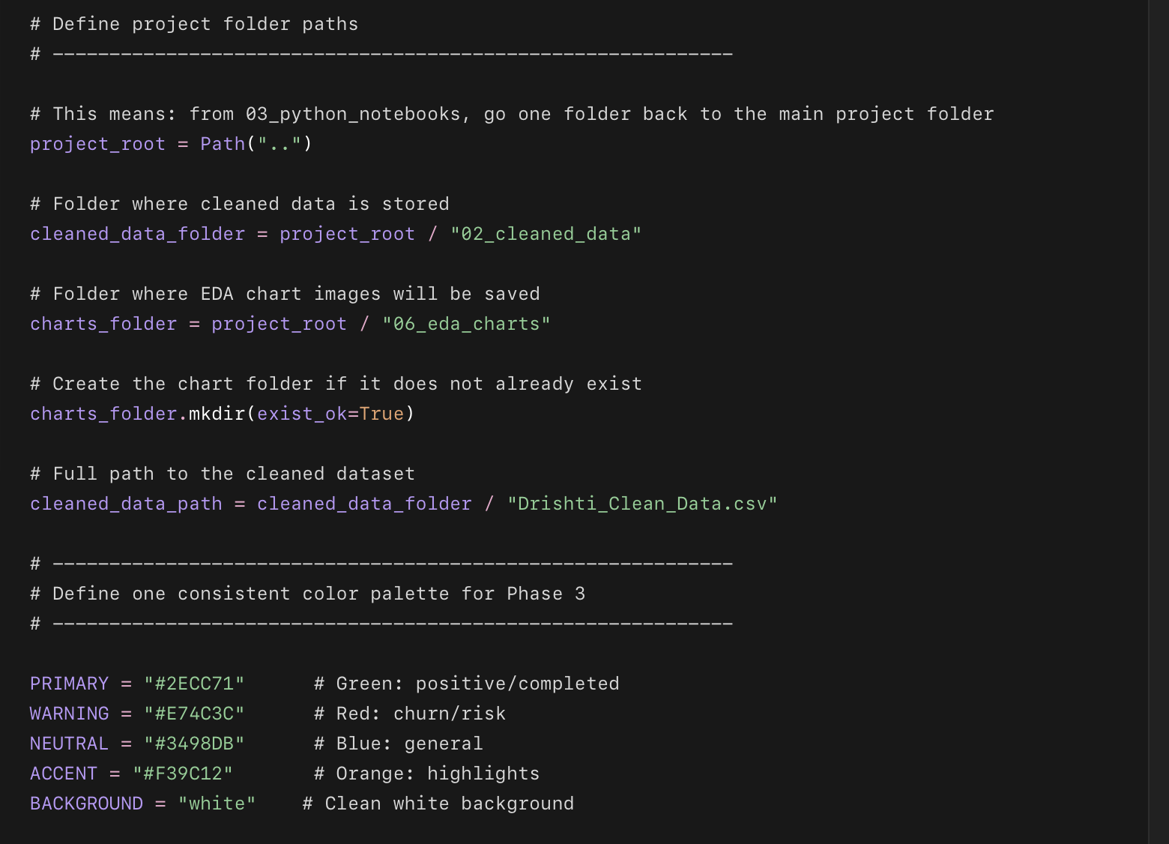
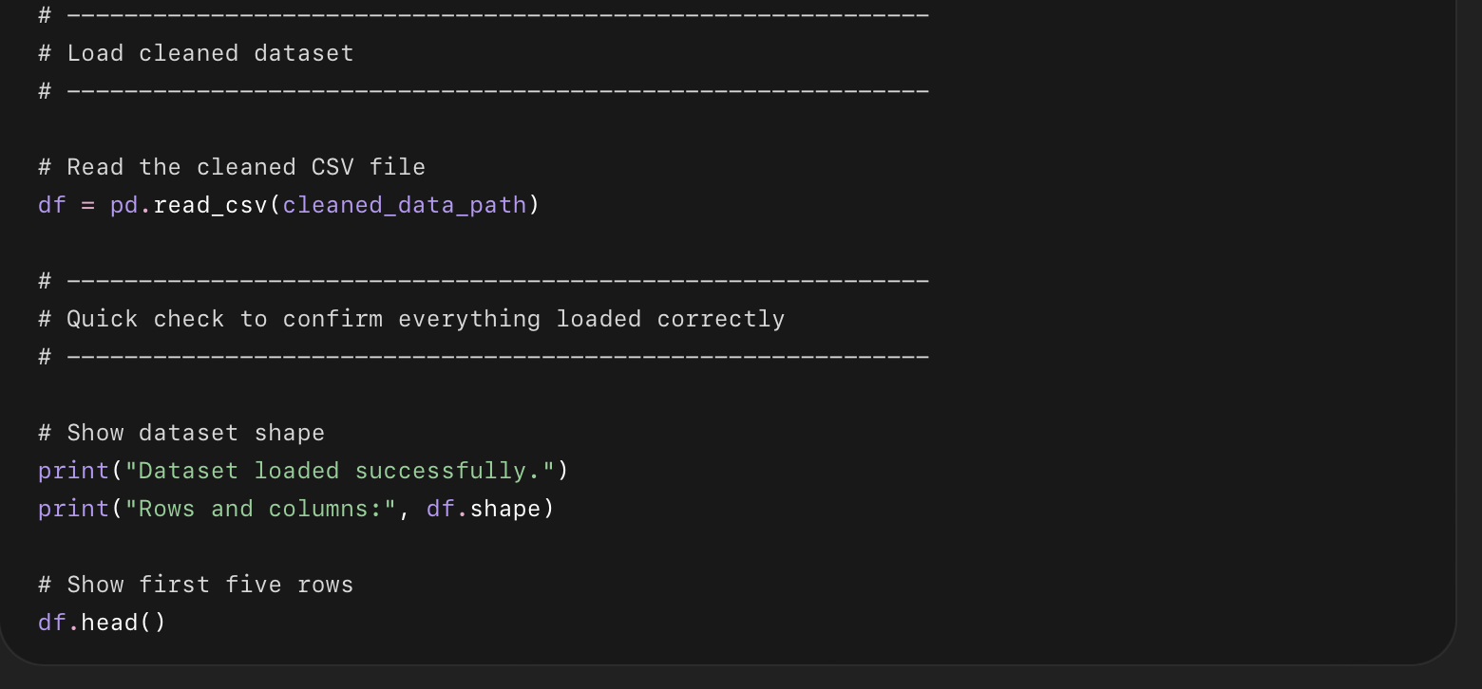

What this code does
This setup code:
- Imports the Python libraries we need.
- Creates clean chart styling.
- Tells Python where your main project folders are.
- Finds your cleaned dataset inside 02_cleaned_data.
- Creates or connects to 06_eda_charts.
- Defines the color palette for all Phase 3 charts.
- Loads your cleaned CSV into df.
- Shows the first 5 rows to confirm everything worked.

Code 2
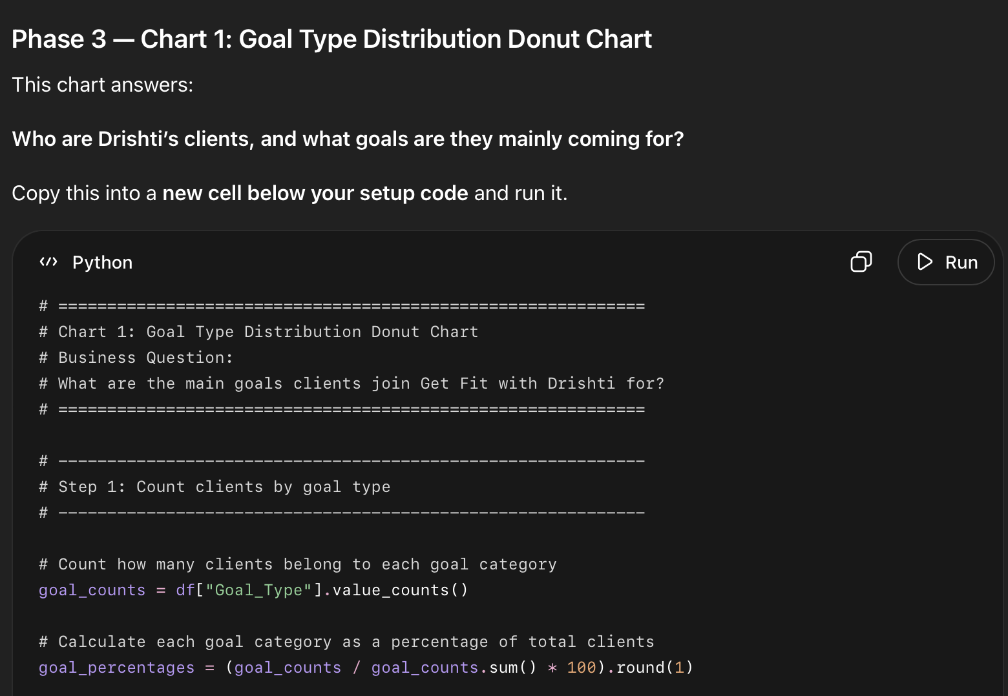
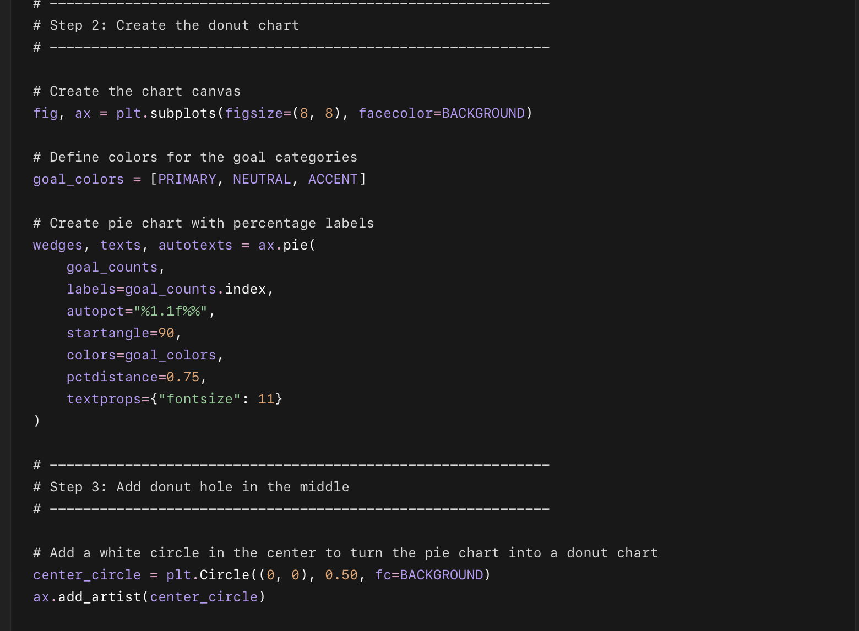
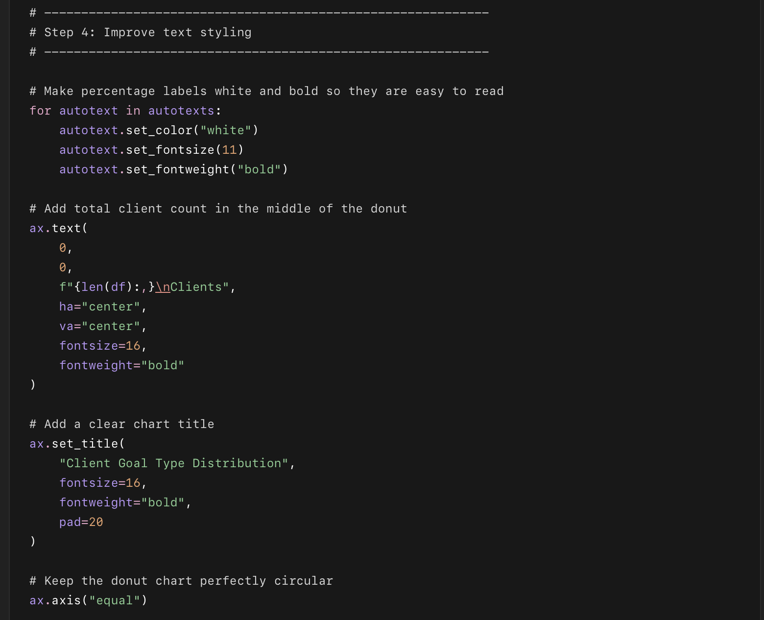
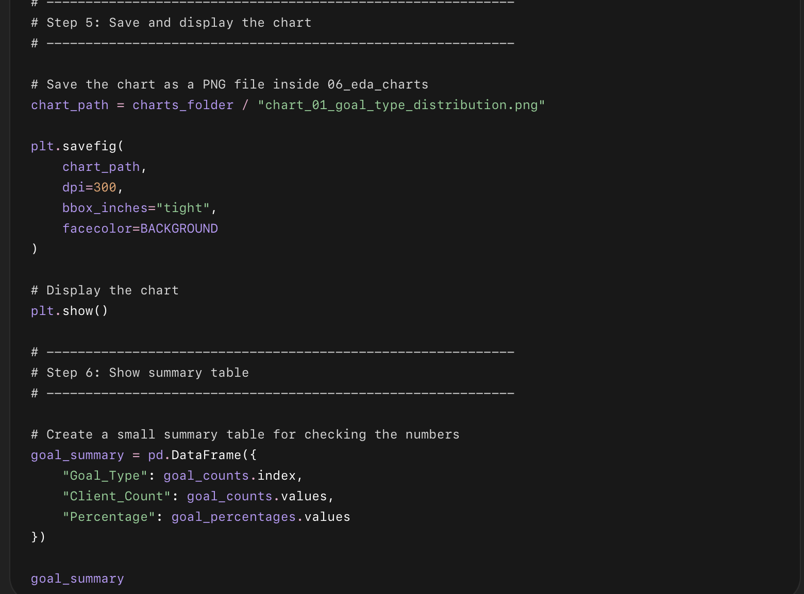
this code does this:
- Counts clients by goal type
  - It checks how many clients joined for:
    - Weight Loss
    - Body Transformation
    - Weight Gain
- Calculates percentages
  - It converts the goal counts into percentage form, like:
    - Weight Loss = around 50%
    - Body Transformation = around 31%
    - Weight Gain = around 19%
- Creates a donut chart
  - It makes a circular chart showing the share of each goal type.
- Uses our project colors
  - Green, blue, and orange are used to keep the chart visually clean and consistent.
- Adds percentage labels
  - Each slice shows the percentage directly on the chart.
- Adds total clients in the center
  - The middle of the donut shows:
3,000
Clients
- Adds a title
  - The chart title is:
Client Goal Type Distribution
- Saves the chart
  - It saves the PNG file inside:
06_eda_charts/chart_01_goal_type_distribution.png
- Shows a summary table
  - At the end, it displays a small table with:
    - Goal type
    - Client count
    - Percentage
This chart is basically answering: “What are most clients coming to Drishti for?”

Chart 2: Lead Source Performance
This chart answers:
Which lead source brings better clients — not just more clients?
We will compare each lead source using two rates:
- Completion Rate
- Goal Achievement Rate
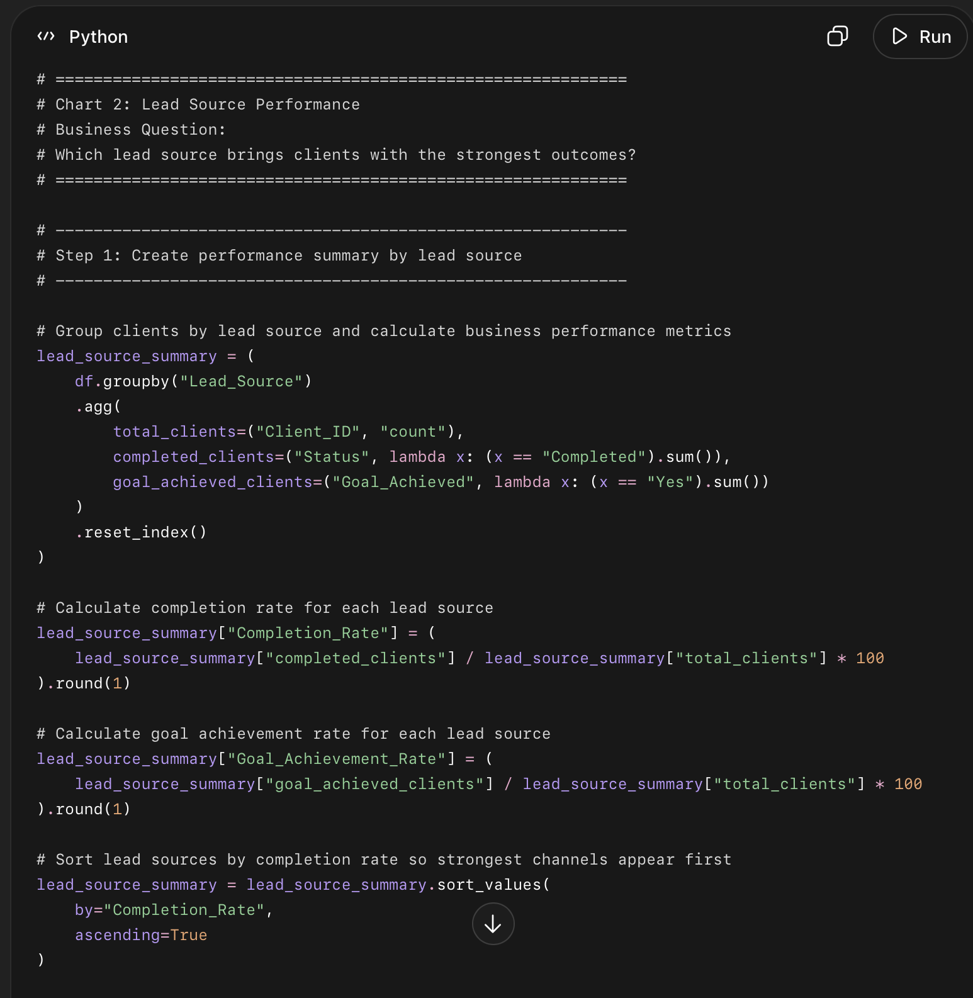
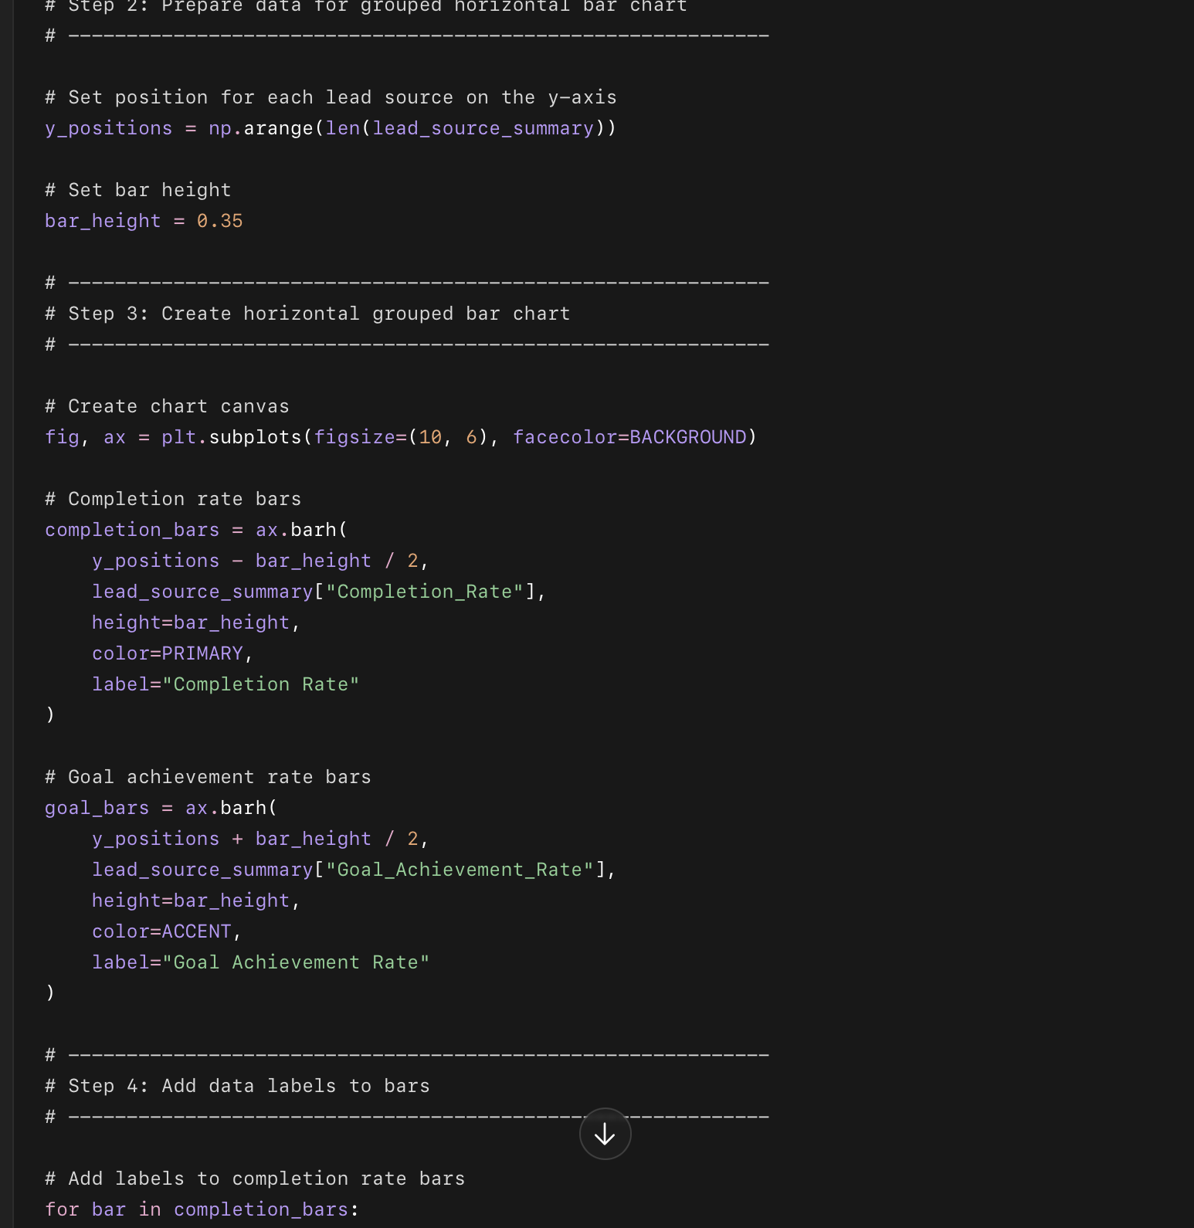
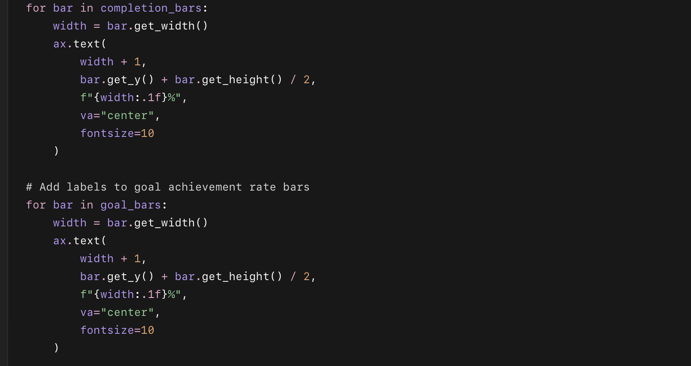
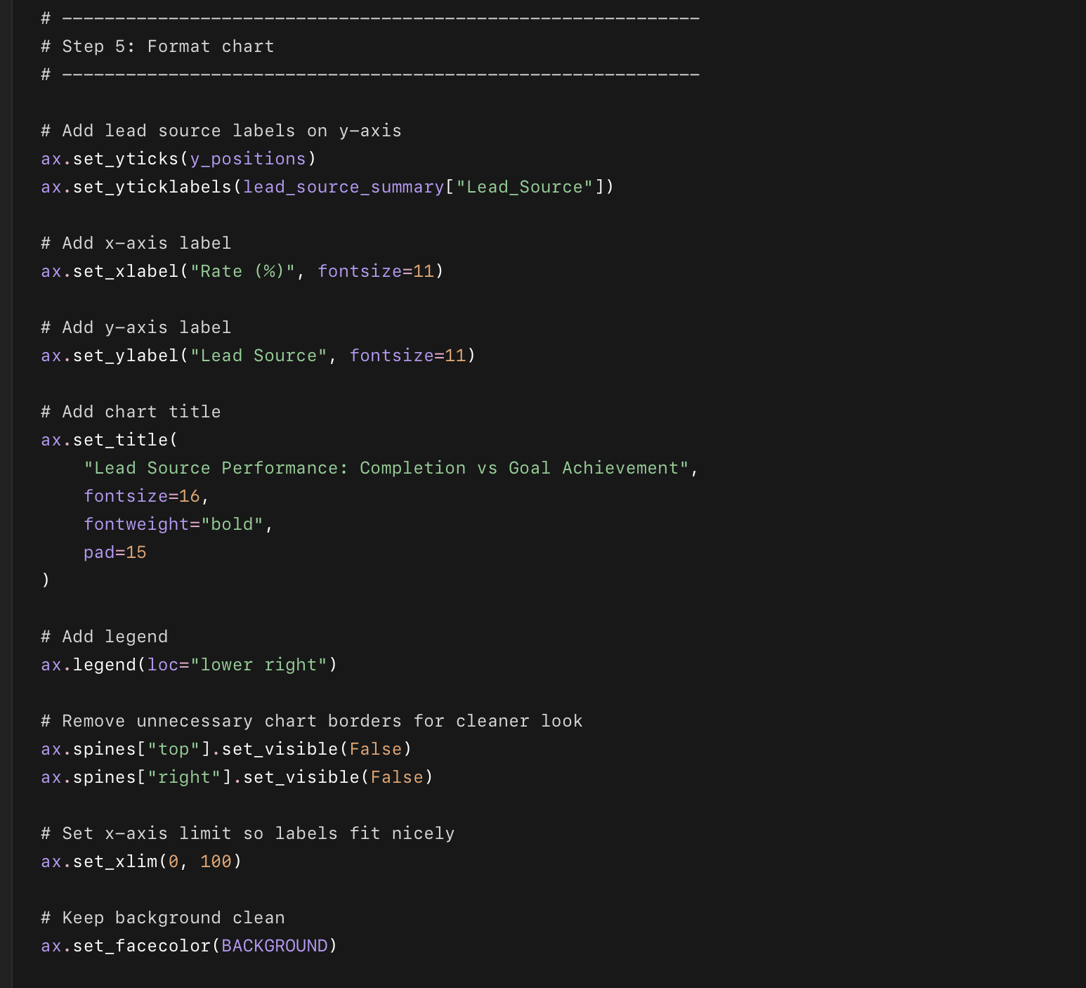
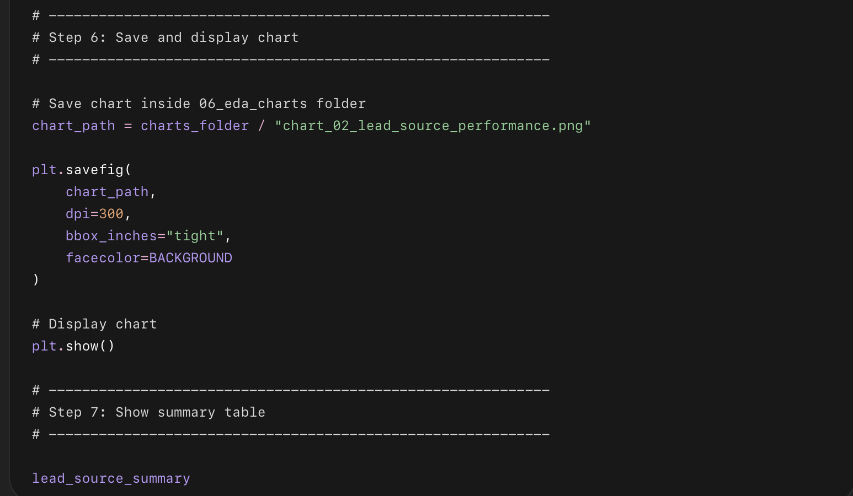

What this code does in simple points
- Groups all clients by Lead_Source.
- Counts how many clients came from each source.
- Counts how many clients completed the program from each source.
- Counts how many clients achieved their goal from each source.
- Calculates:
  - Completion rate
  - Goal achievement rate
- Creates a horizontal grouped bar chart.
- Shows both rates side by side for each lead source.
- Adds percentage labels on each bar.
- Saves the chart inside:
06_eda_charts/chart_02_lead_source_performance.png

Phase 3 — Chart 3: Age Distribution by Goal Type
This chart answers:
Who is Drishti actually coaching, and do different age groups come for different goals?
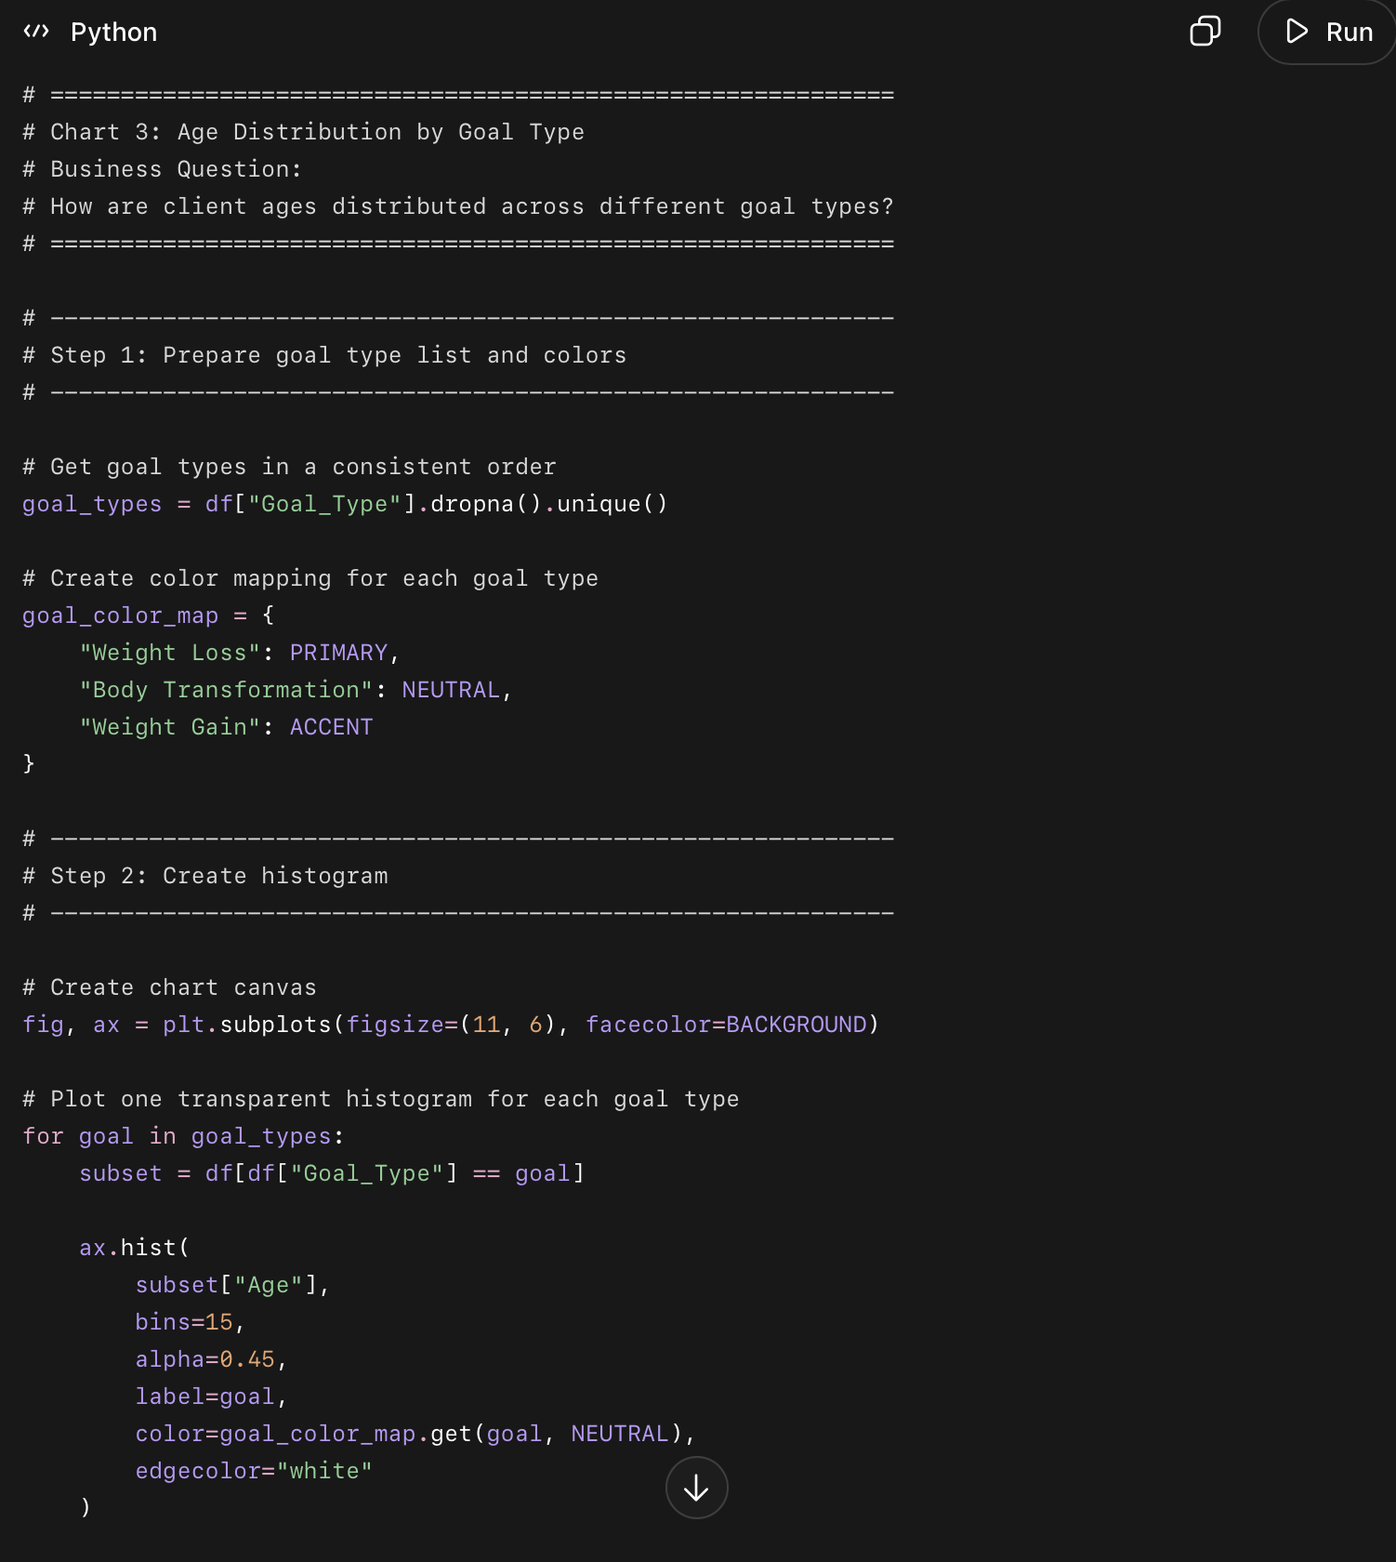
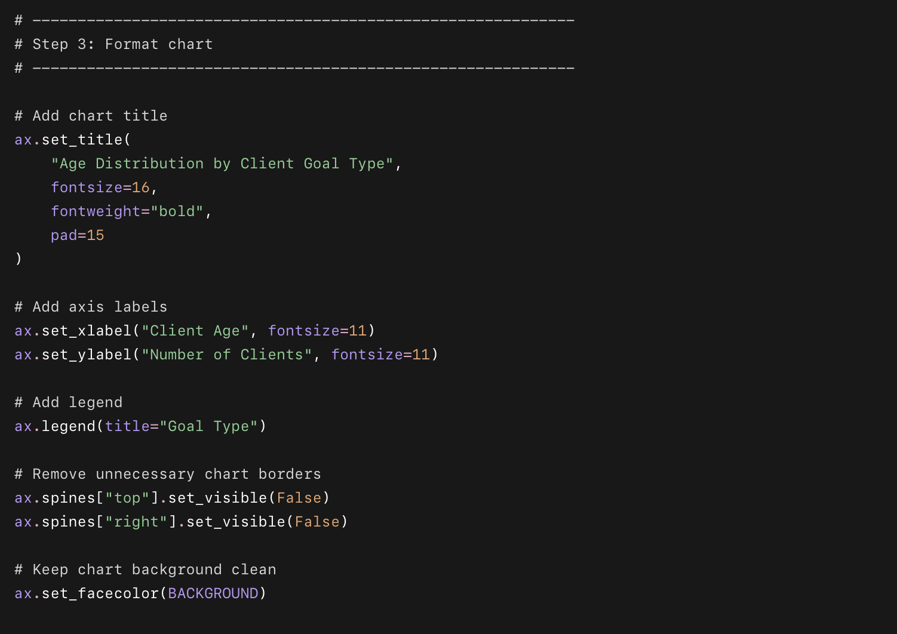
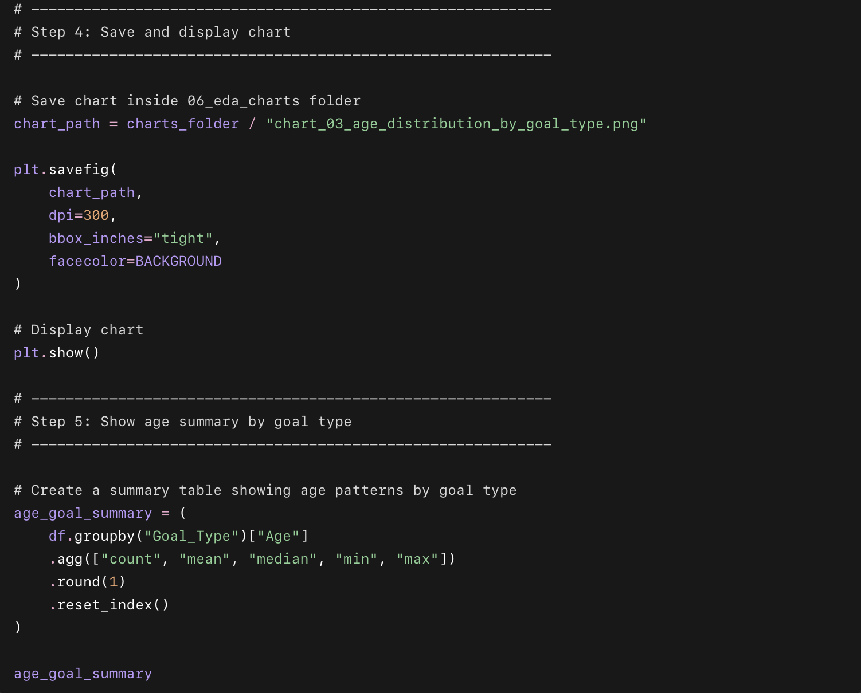

What this code does in simple points
- Takes the Age column and separates clients by Goal_Type.
- Creates overlapping histograms for each goal type.
- Uses transparent colors so we can compare the age groups together.
- Shows whether certain goals are more common in younger or older clients.
- Saves the chart as:
06_eda_charts/chart_03_age_distribution_by_goal_type.png
- Displays a summary table with:
  - Client count
  - Average age
  - Median age
  - Youngest client
  - Oldest client

Phase 3 — Chart 4: Goal Achievement Within Each Goal Type
This chart answers:
Which goal type succeeds the most?
We will create a stacked bar chart showing how many clients achieved Yes / Partial / No / Ongoing inside each goal type.
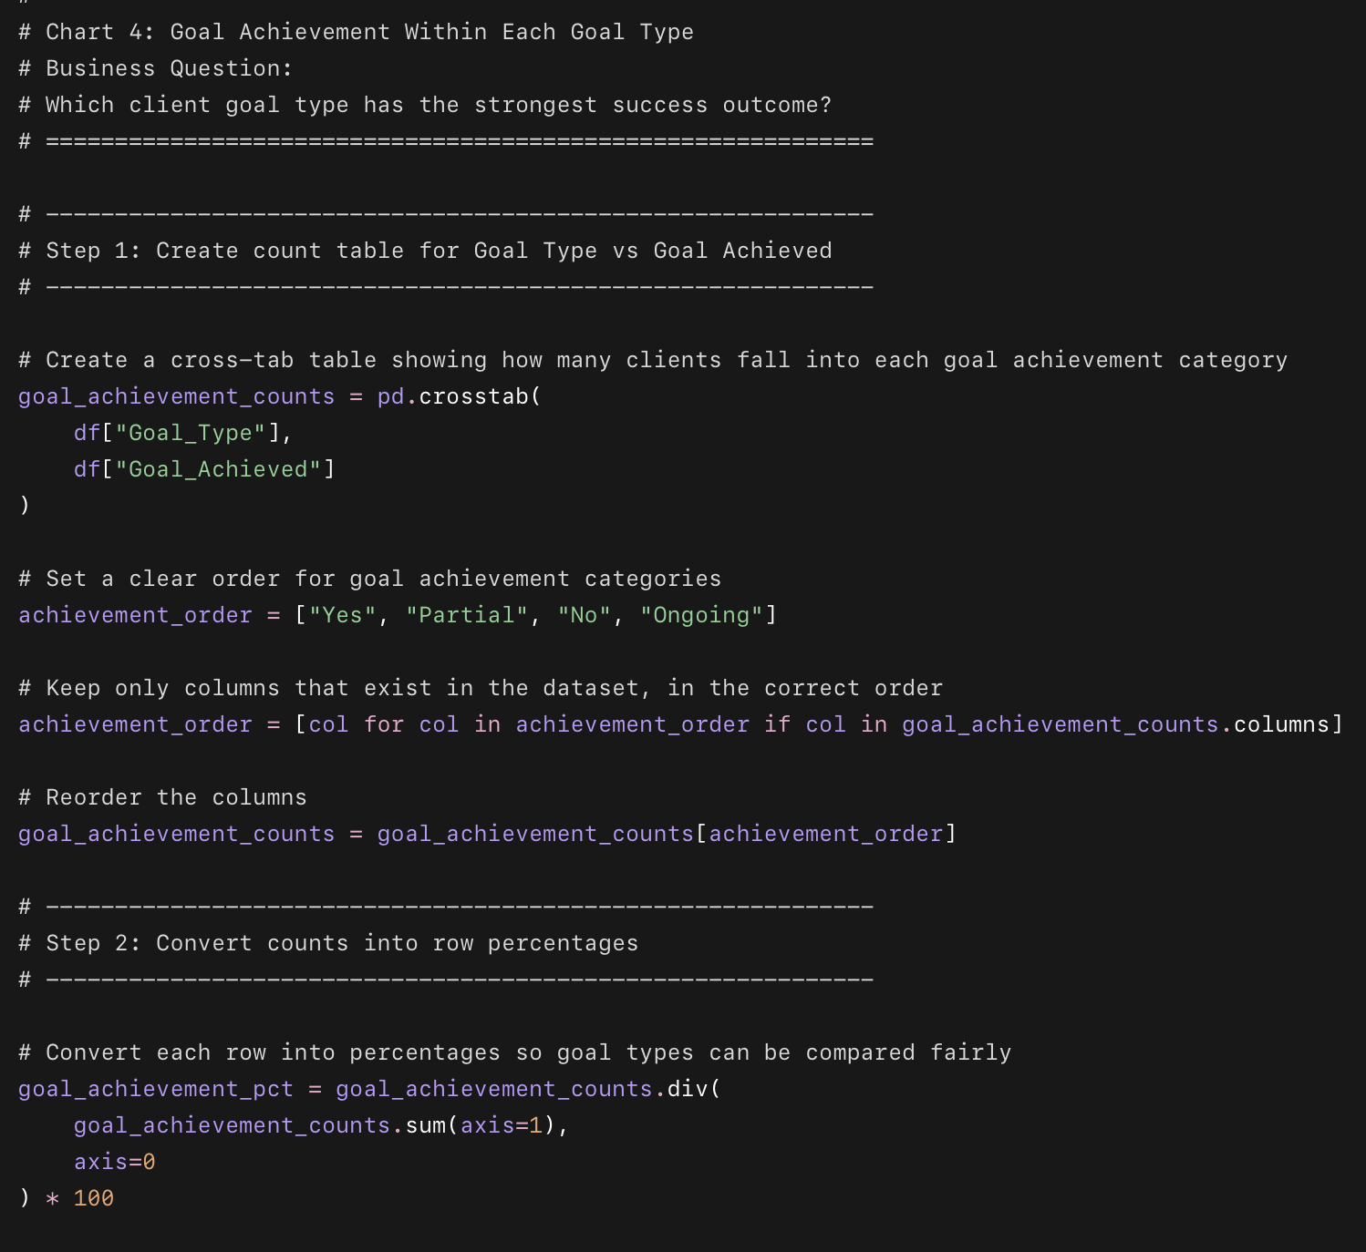
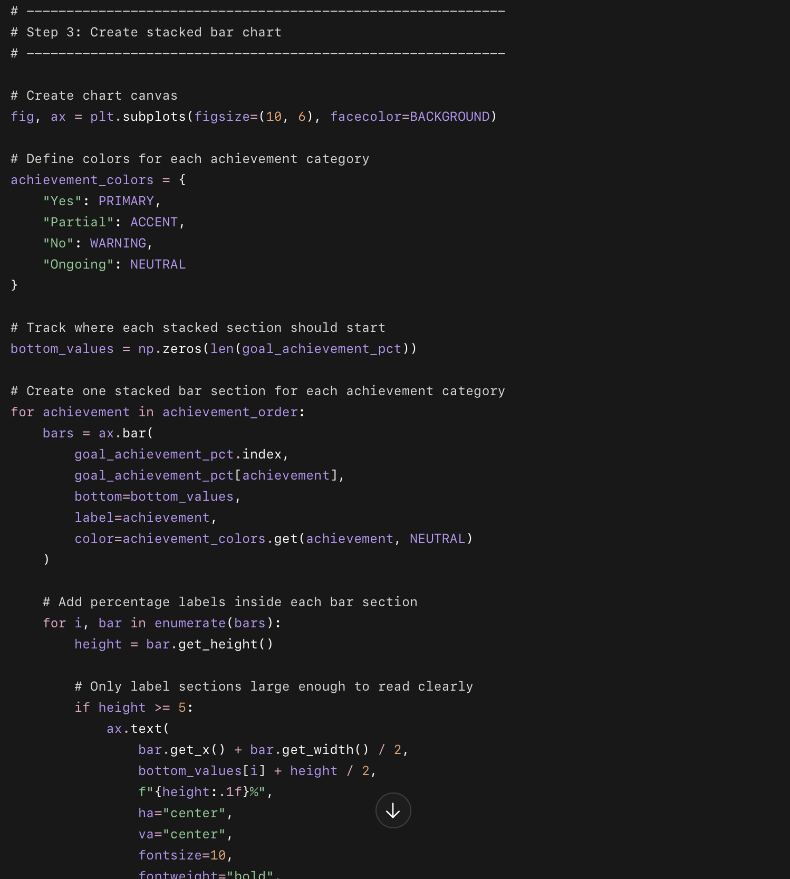
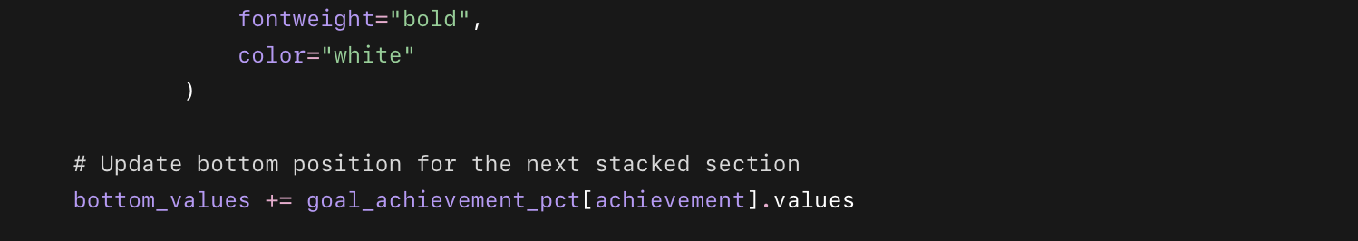
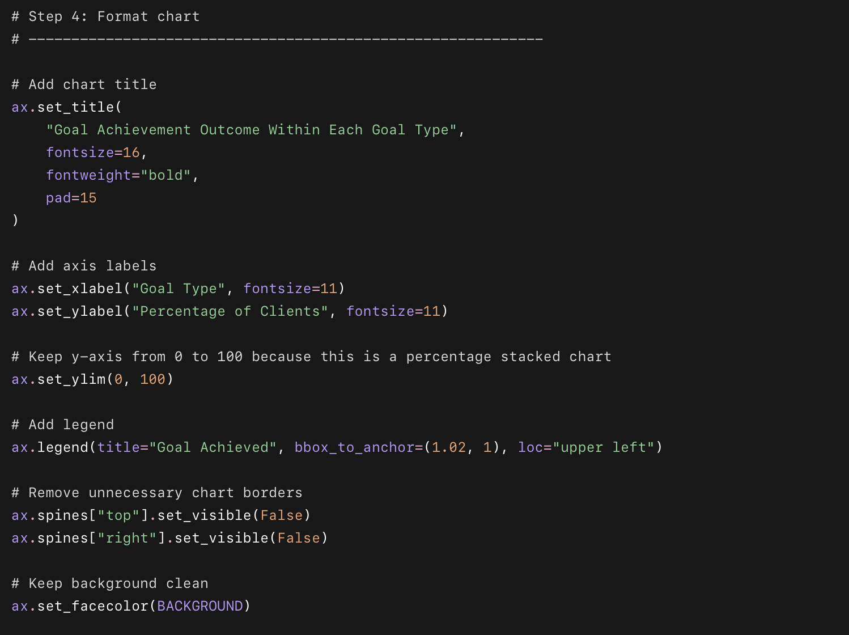
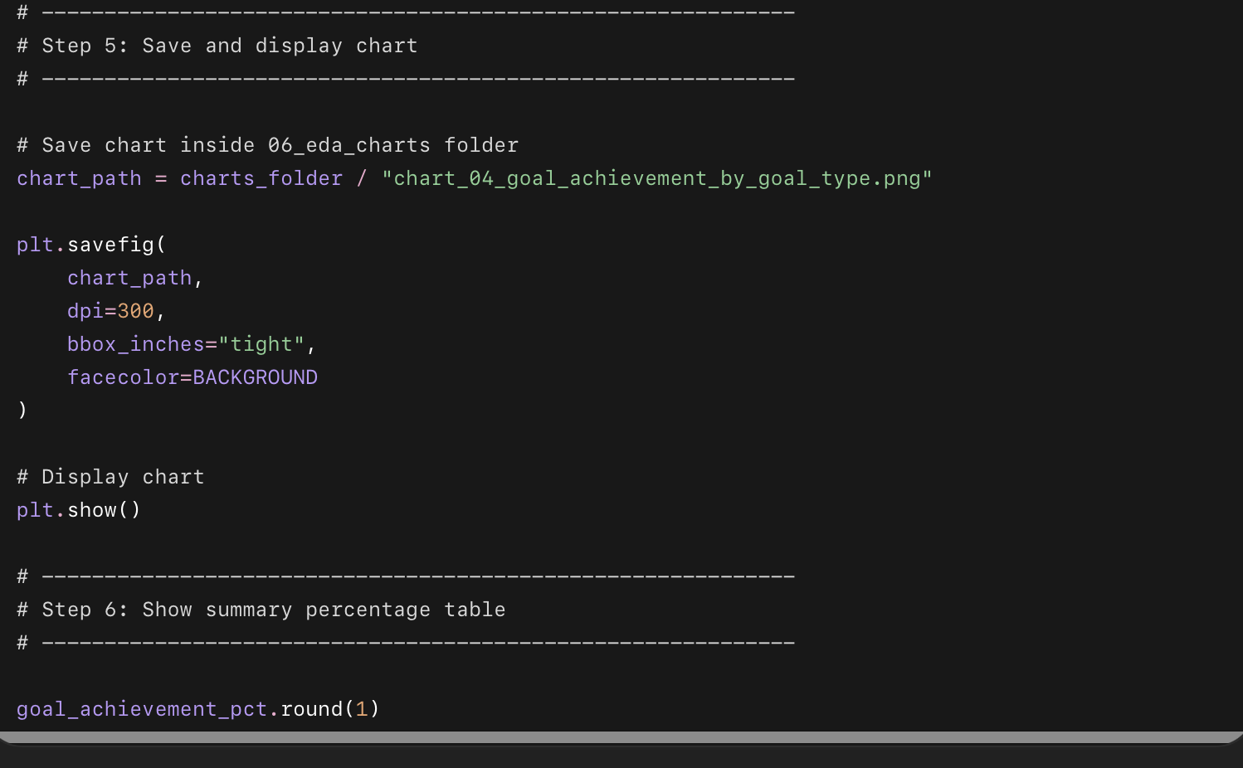

What this code does in simple points
- Compares Goal_Type with Goal_Achieved.
- Counts how many clients had each outcome:
  - Yes
  - Partial
  - No
  - Ongoing
- Converts the counts into percentages.
- Creates a stacked bar chart for each goal type.
- Shows which goal types have higher success, partial success, and failure rates.
- Saves the chart as:
06_eda_charts/chart_04_goal_achievement_by_goal_type.png

Phase 3 — Chart 5: Check-in Rate Heatmap
This chart answers:
Which types of clients engage most consistently?
We will compare average Checkin_Rate_Pct across:
Daily_Schedule × Motivation_Level_Start
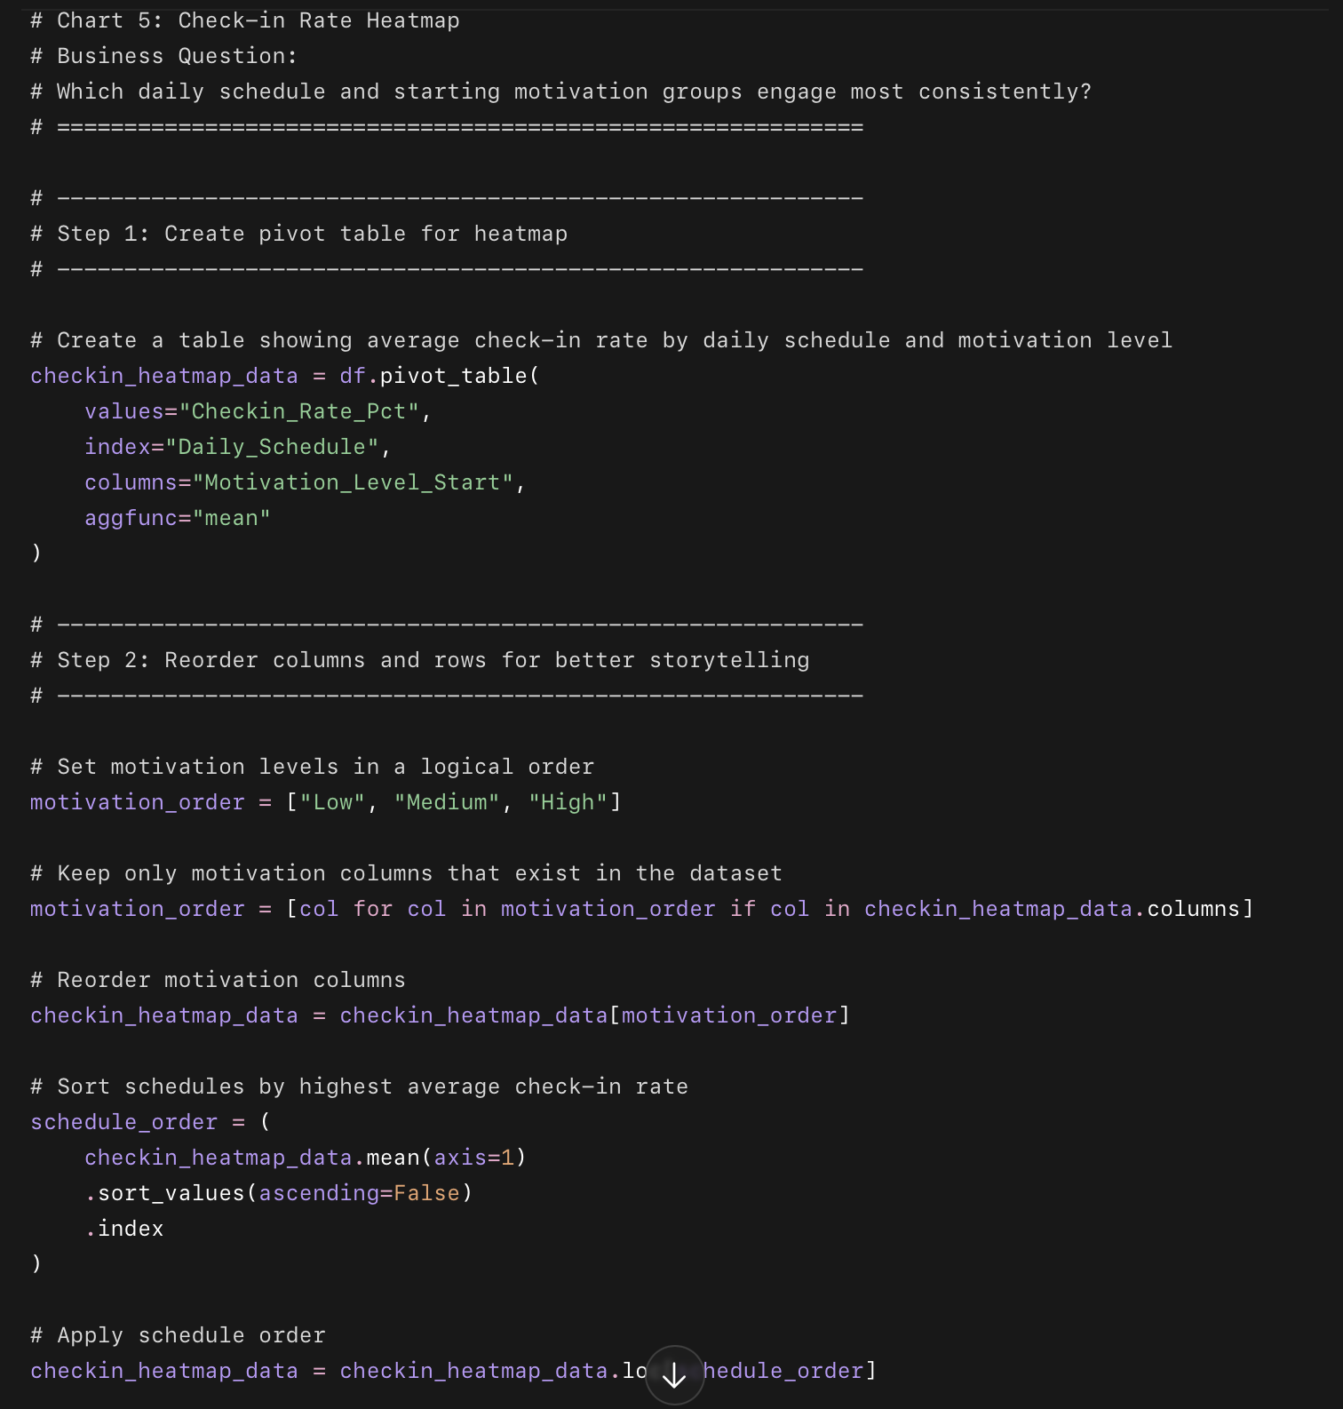
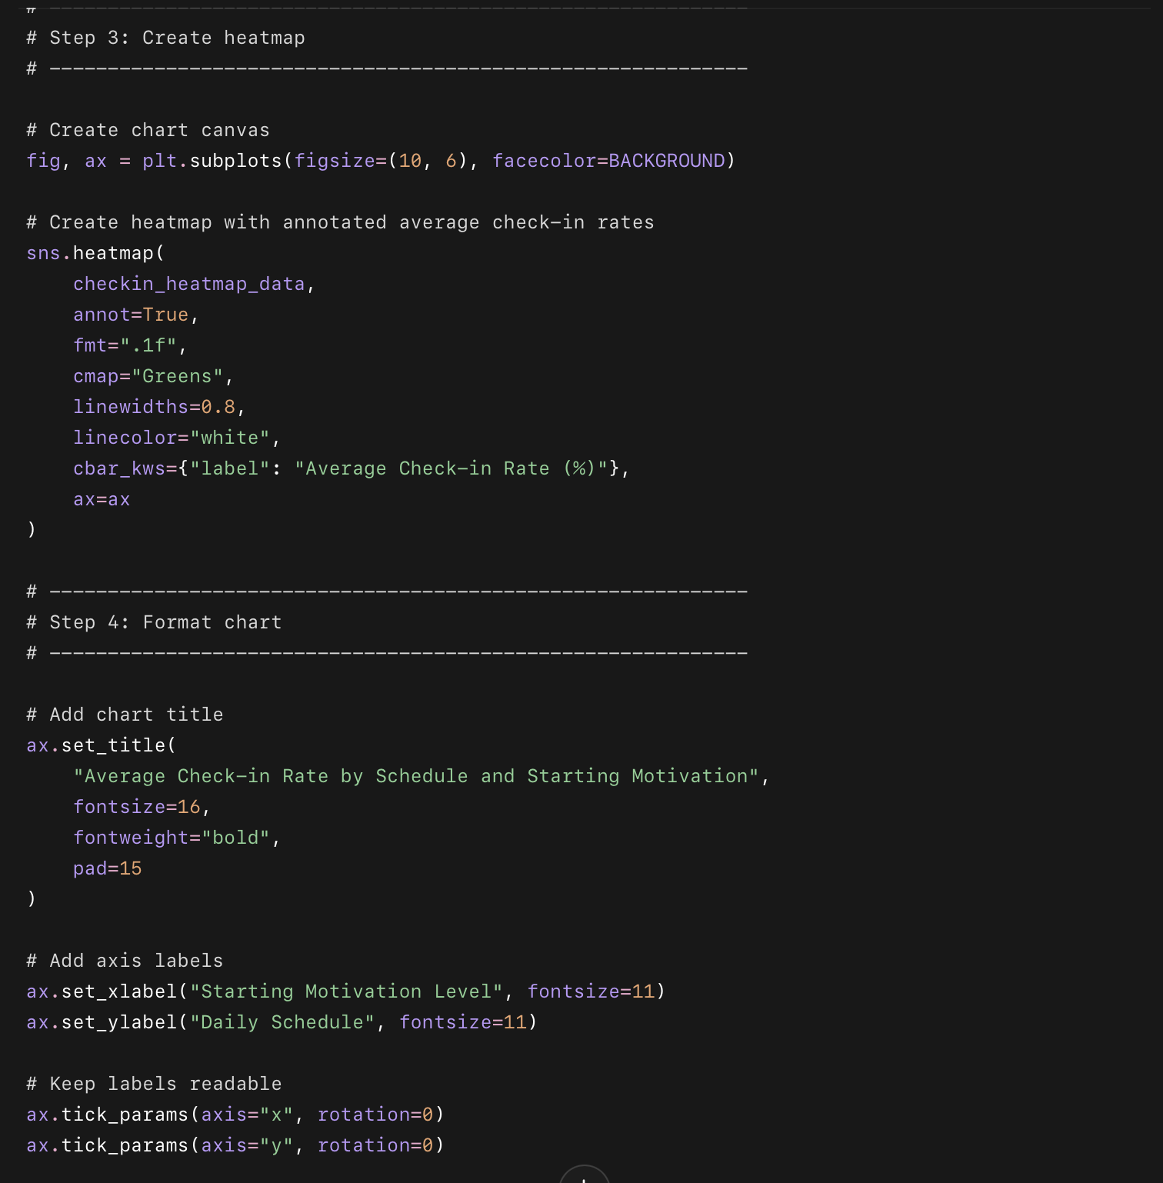
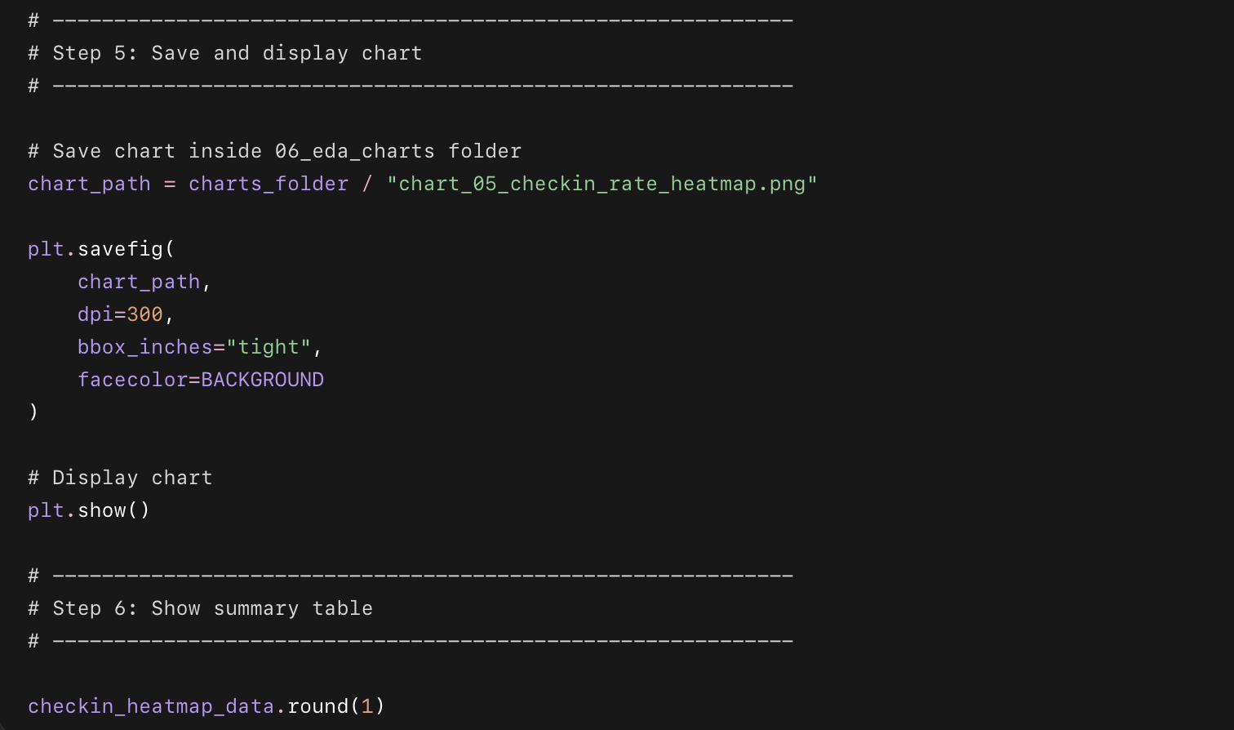

What this code does in simple points
- Takes Checkin_Rate_Pct.
- Groups it by:
  - Daily_Schedule
  - Motivation_Level_Start
- Calculates the average check-in rate for each combination.
- Creates a heatmap where darker green means stronger engagement.
- Adds the exact average value inside each cell.
- Saves the chart as:
06_eda_charts/chart_05_checkin_rate_heatmap.png

Chart 6: Client Journey Funnel
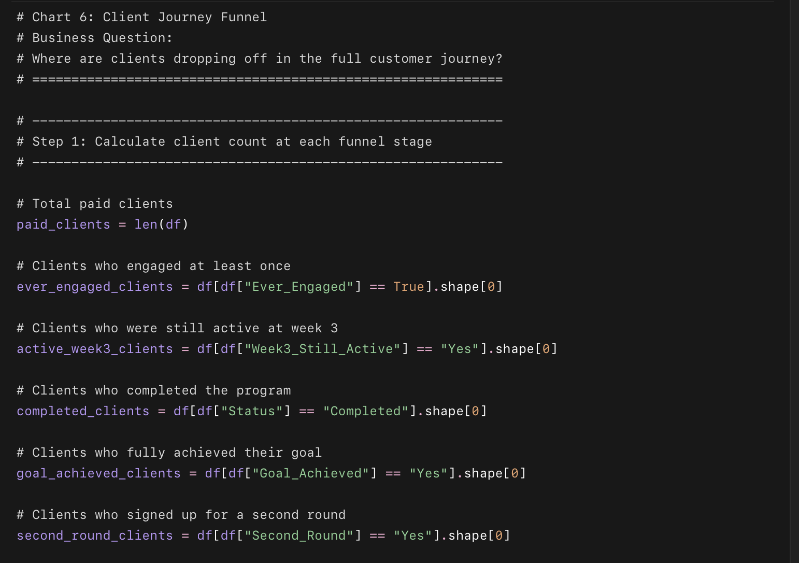
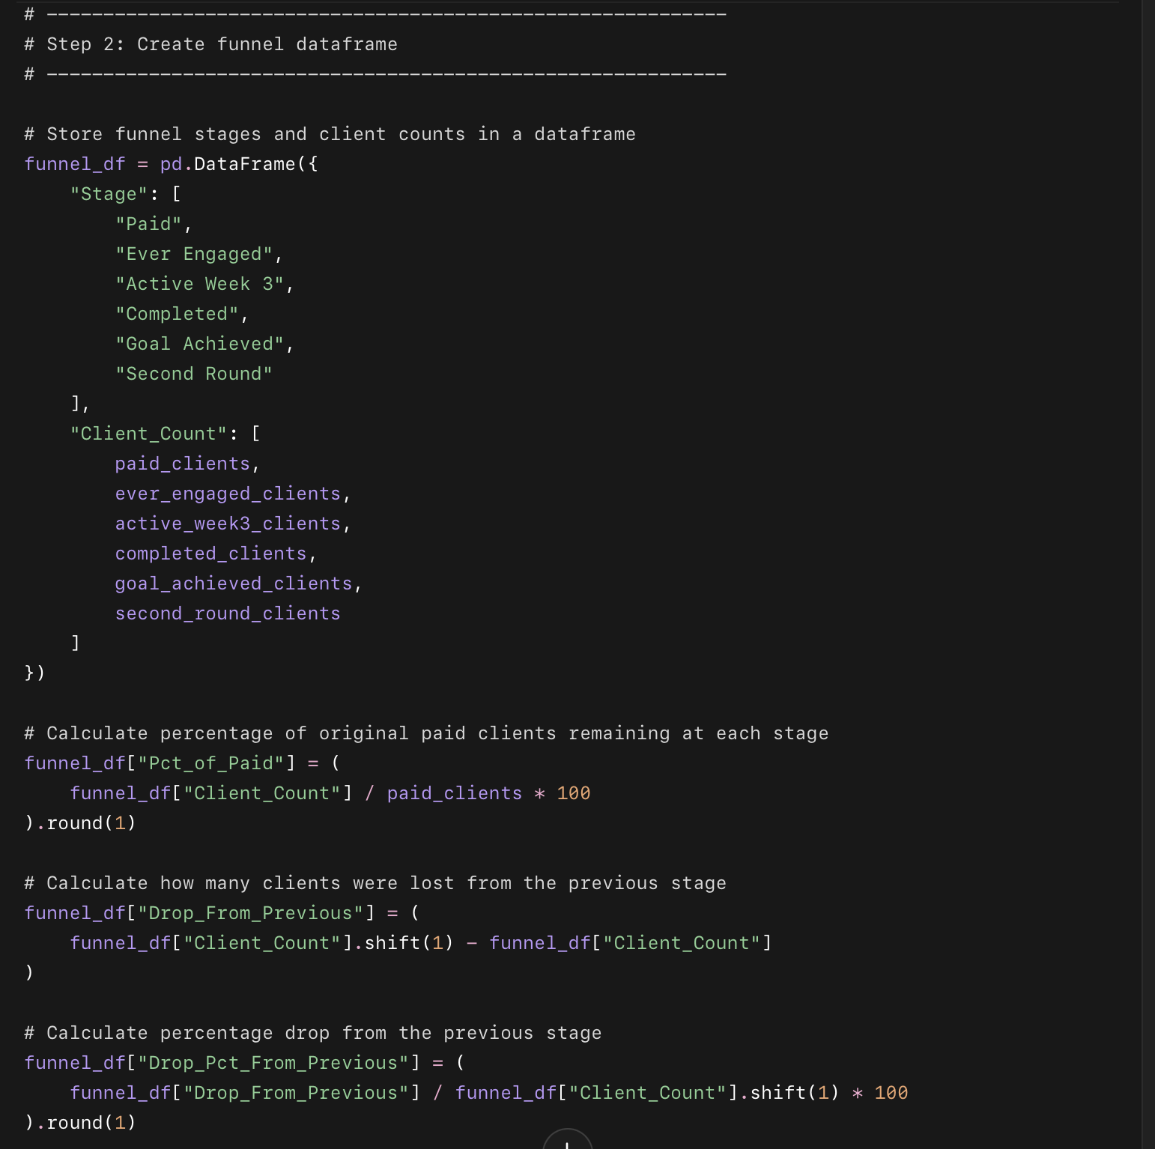
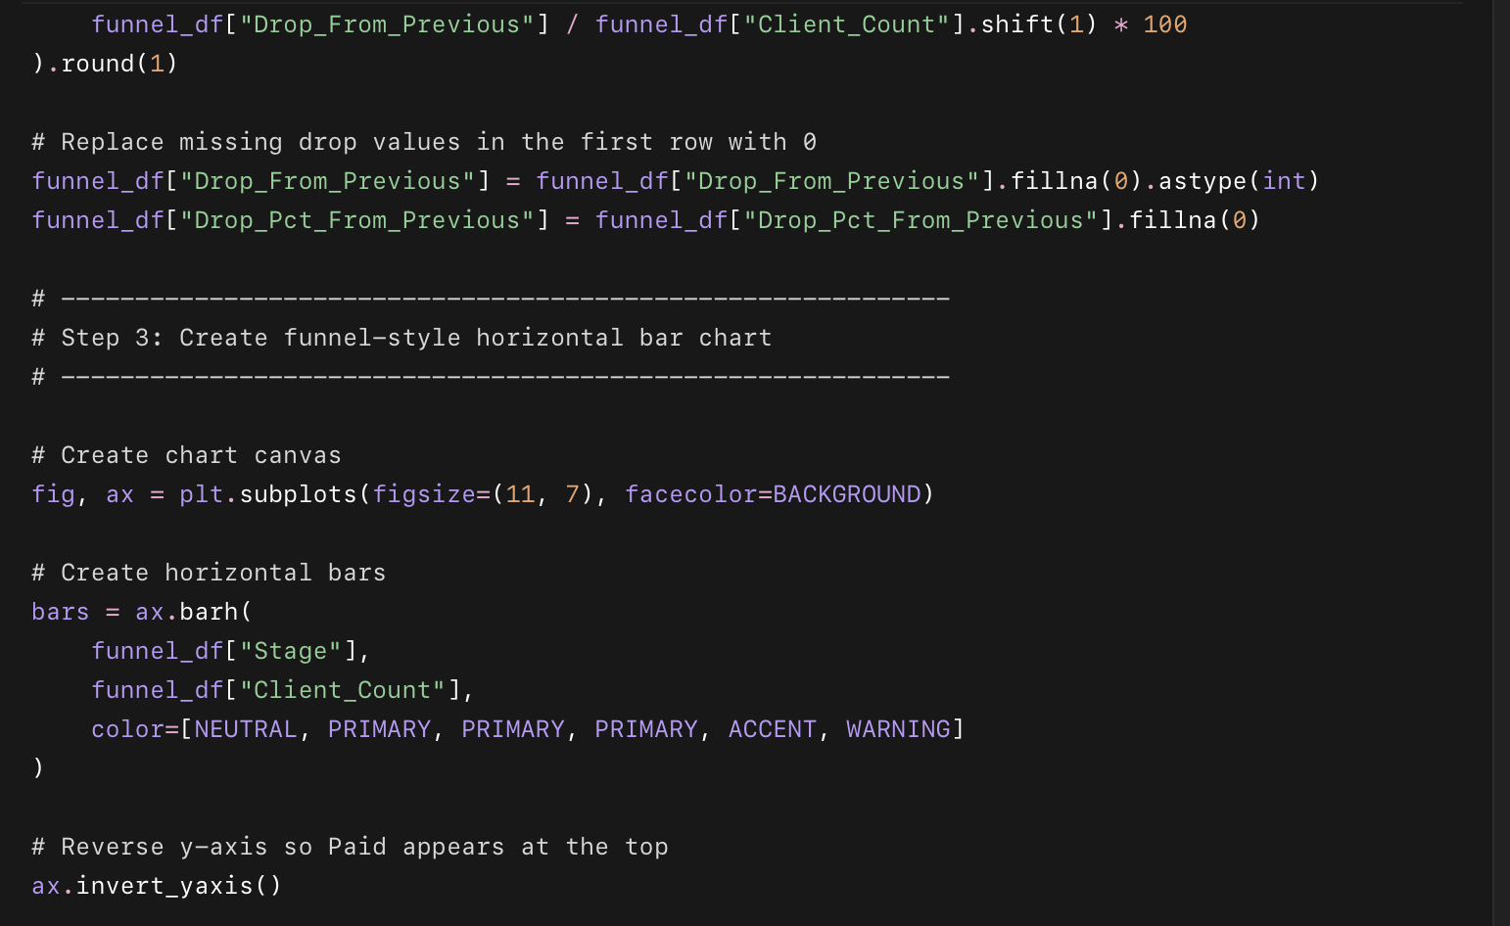
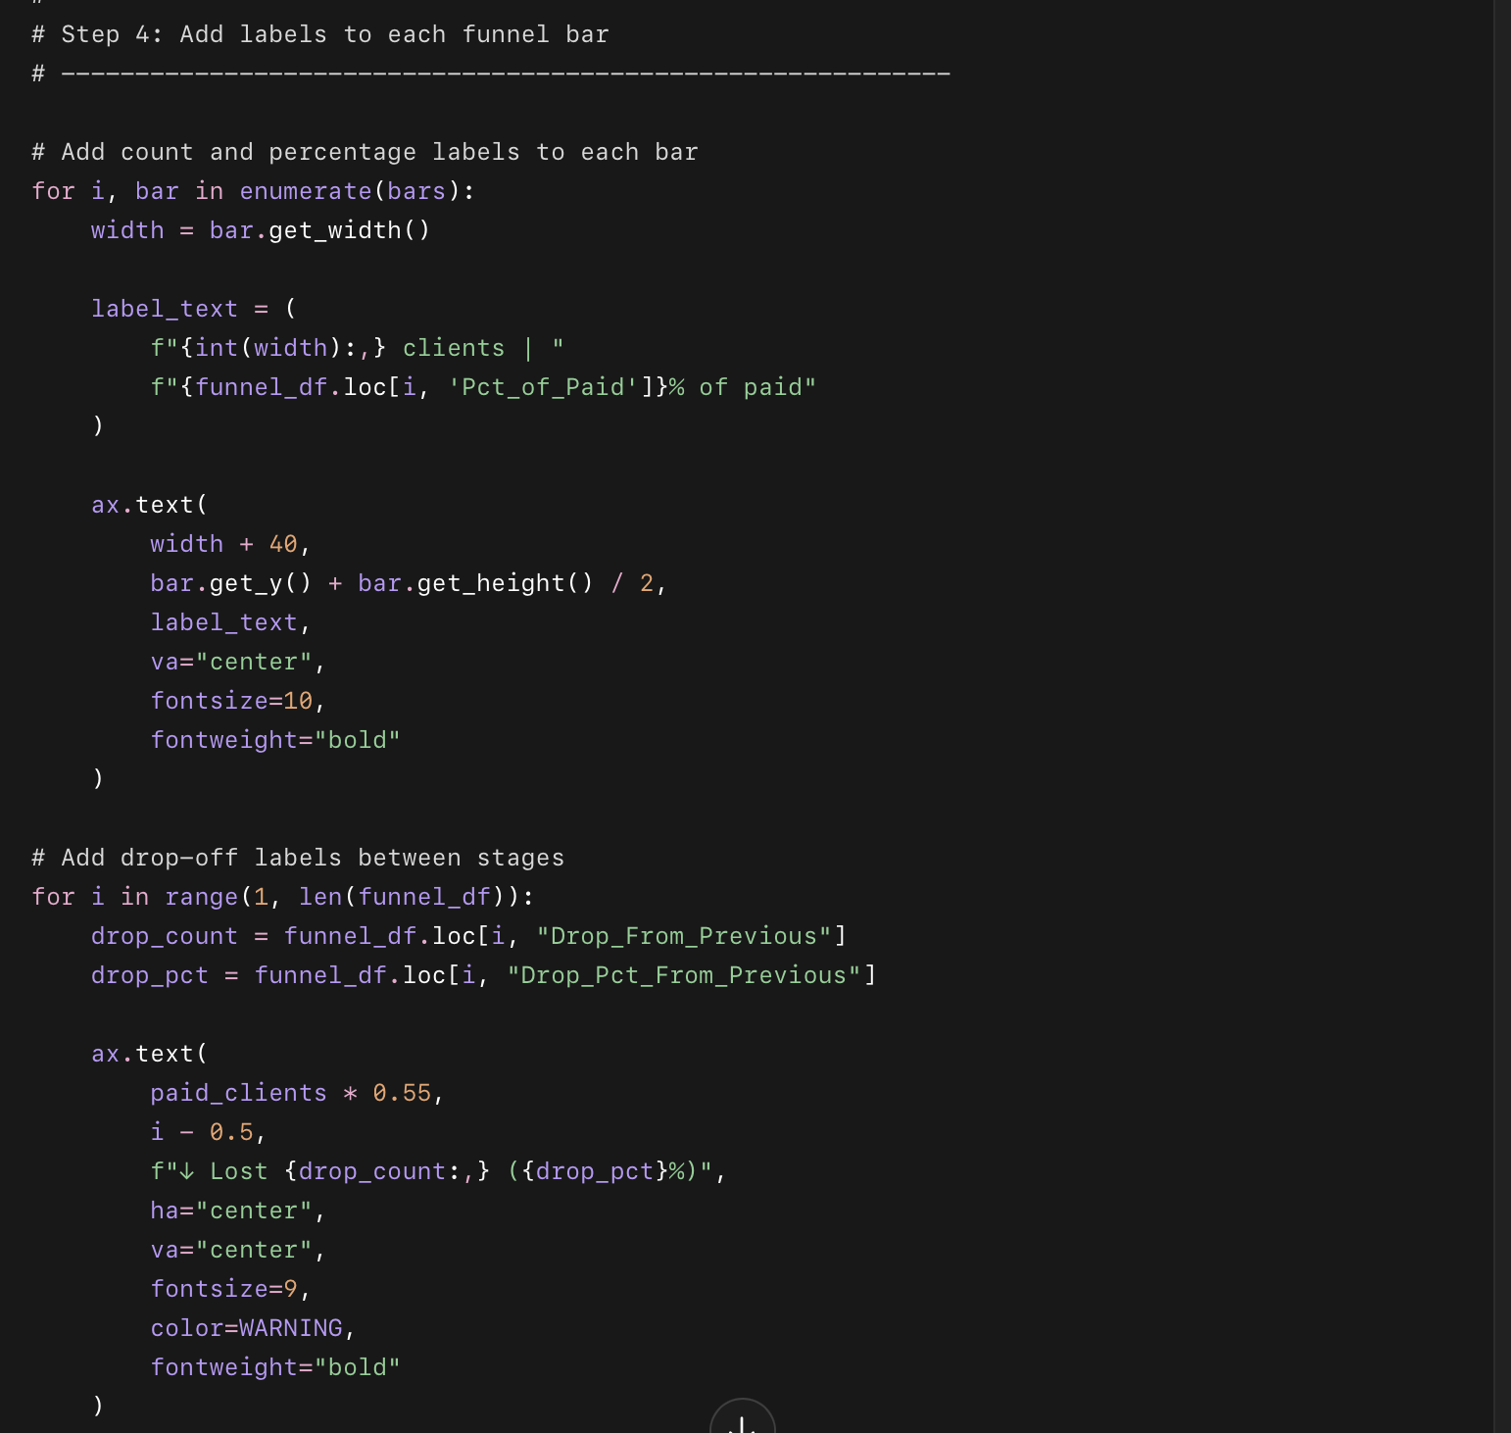
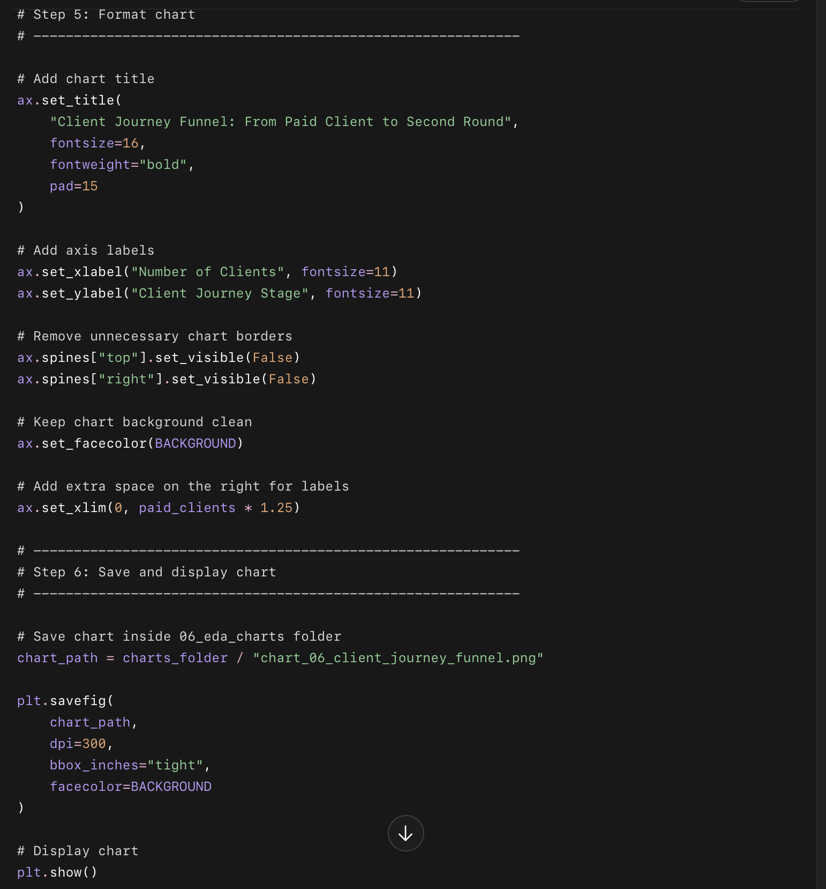
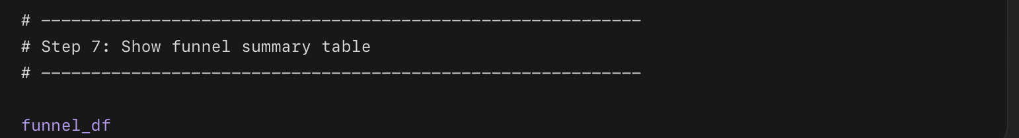
What this code do?
- Counts total paid clients
  - Counts all rows in the dataset.
- Counts clients who engaged
  - Checks how many clients had Ever_Engaged = True.
- Counts clients active at week 3
  - Checks how many clients had Week3_Still_Active = Yes.
- Counts completed clients
  - Checks how many clients had Status = Completed.
- Counts clients who achieved their goal
  - Checks how many clients had Goal_Achieved = Yes.
- Counts second-round clients
  - Checks how many clients had Second_Round = Yes.
- Creates a funnel table
  - Stores each stage and client count in funnel_df.
- Calculates percentage of paid clients
  - Shows what percent of the original 3,000 clients reached each stage.
- Calculates drop-off between stages
  - Shows how many clients were lost from one stage to the next.
- Creates a horizontal funnel chart
- Visualizes the client journey from paid client to second-round client.
- Adds labels to the chart
- Shows client count, percentage, and lost clients.
- Saves the chart
- Saves it inside:
06_eda_charts/chart_06_client_journey_funnel.png
In simple words: this code shows where clients drop off in Drishti’s coaching journey.

Phase 3 — Chart 7: Dropout Reasons + Win-Back Rate
This chart answers:
When clients drop out, why do they drop — and which reasons are most recoverable?
This is the comeback story chart.
We will show:
- Dropout reason count as bars
- Win-back rate as a line on a second axis

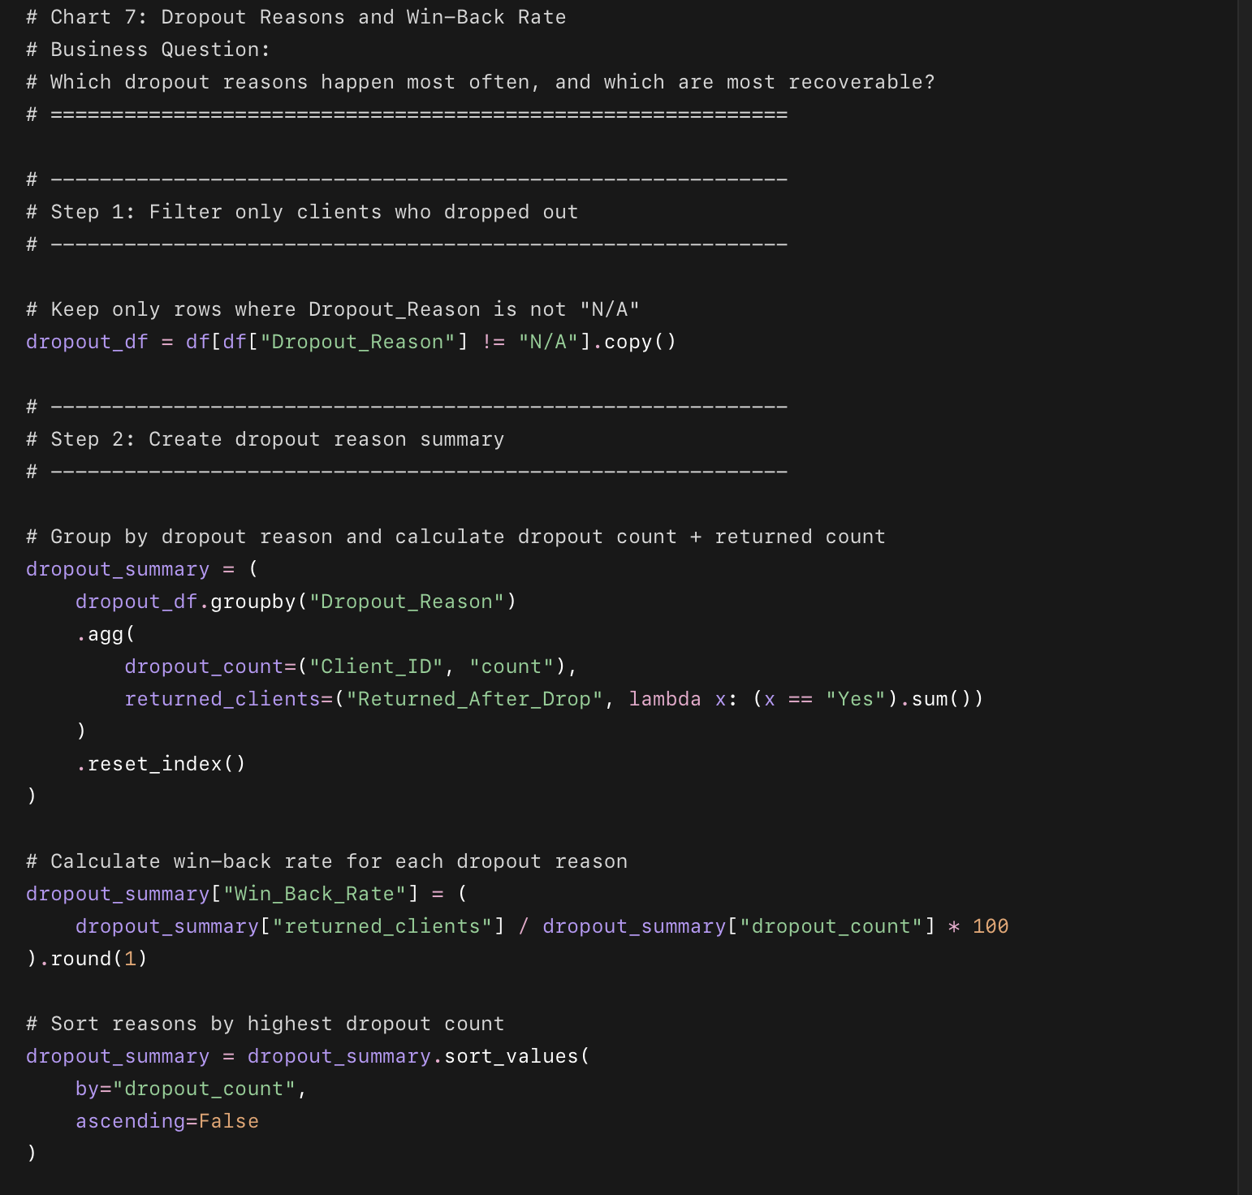
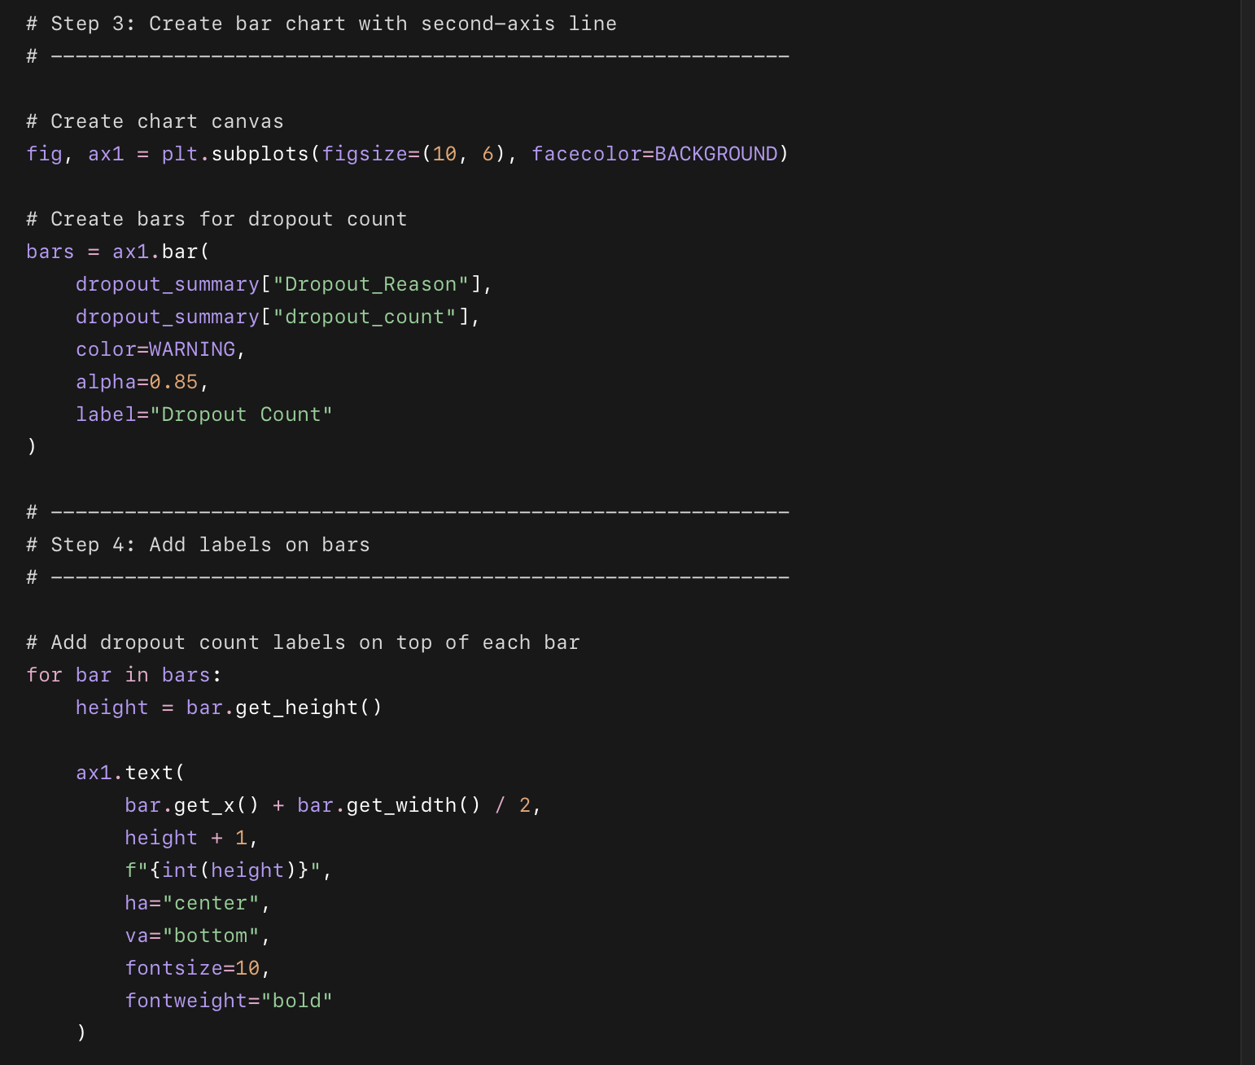
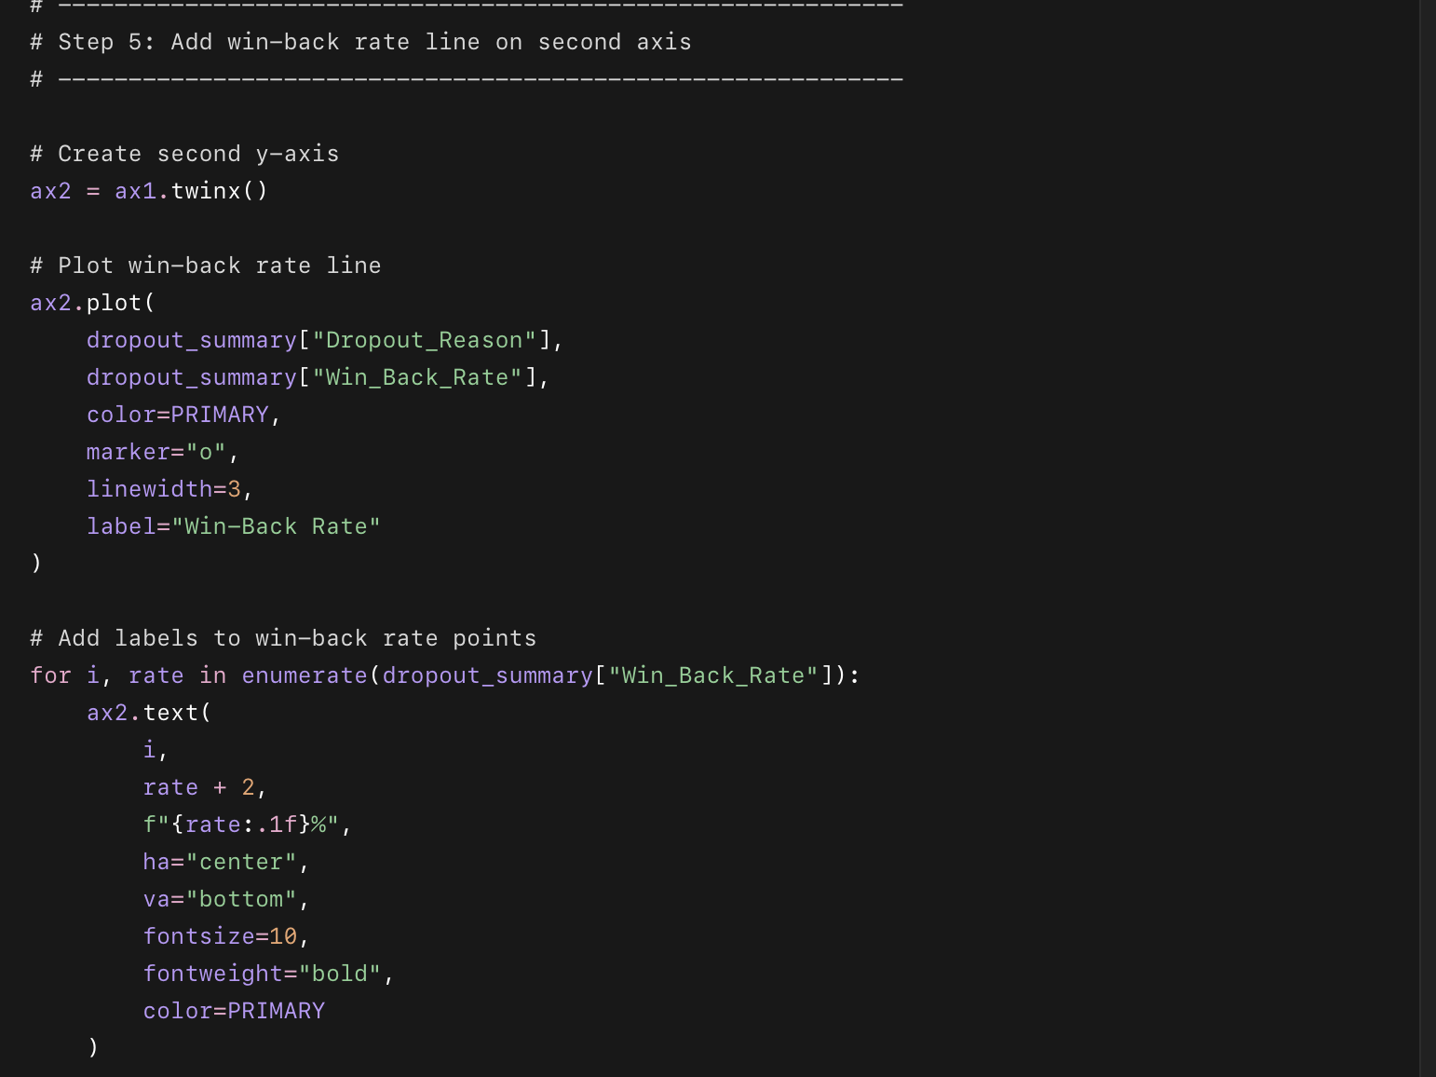
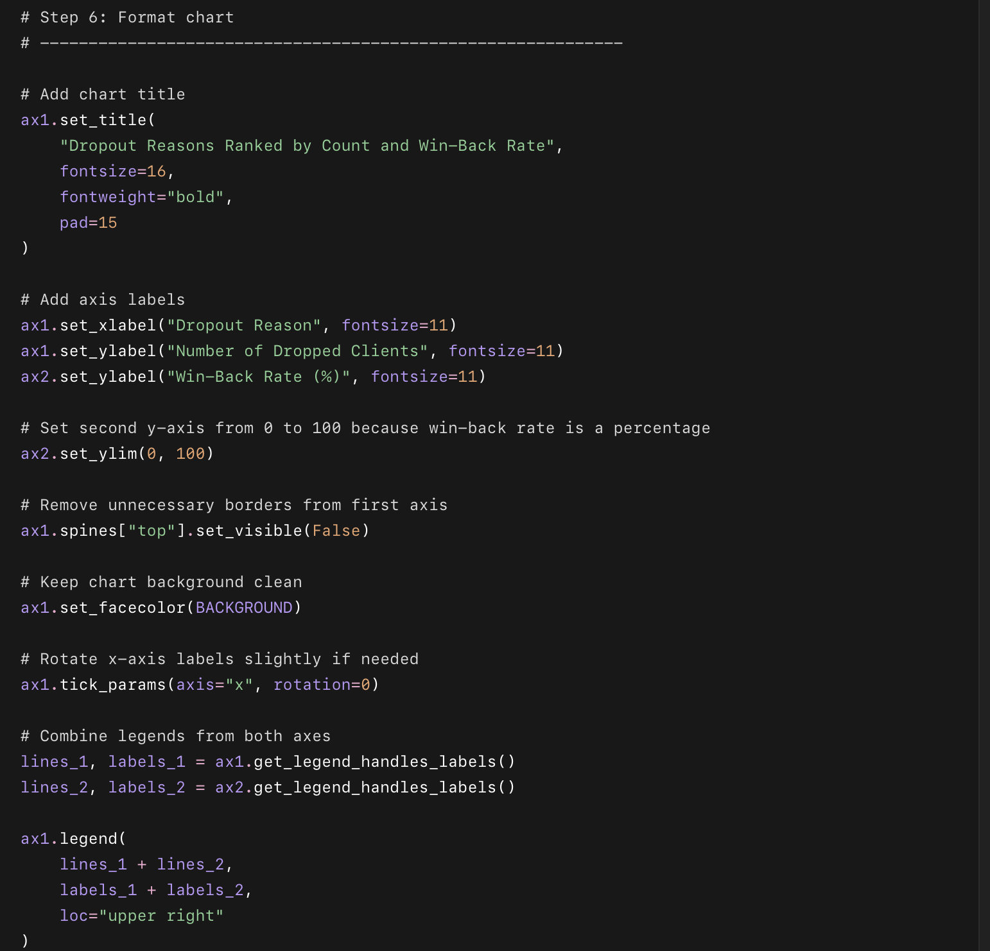
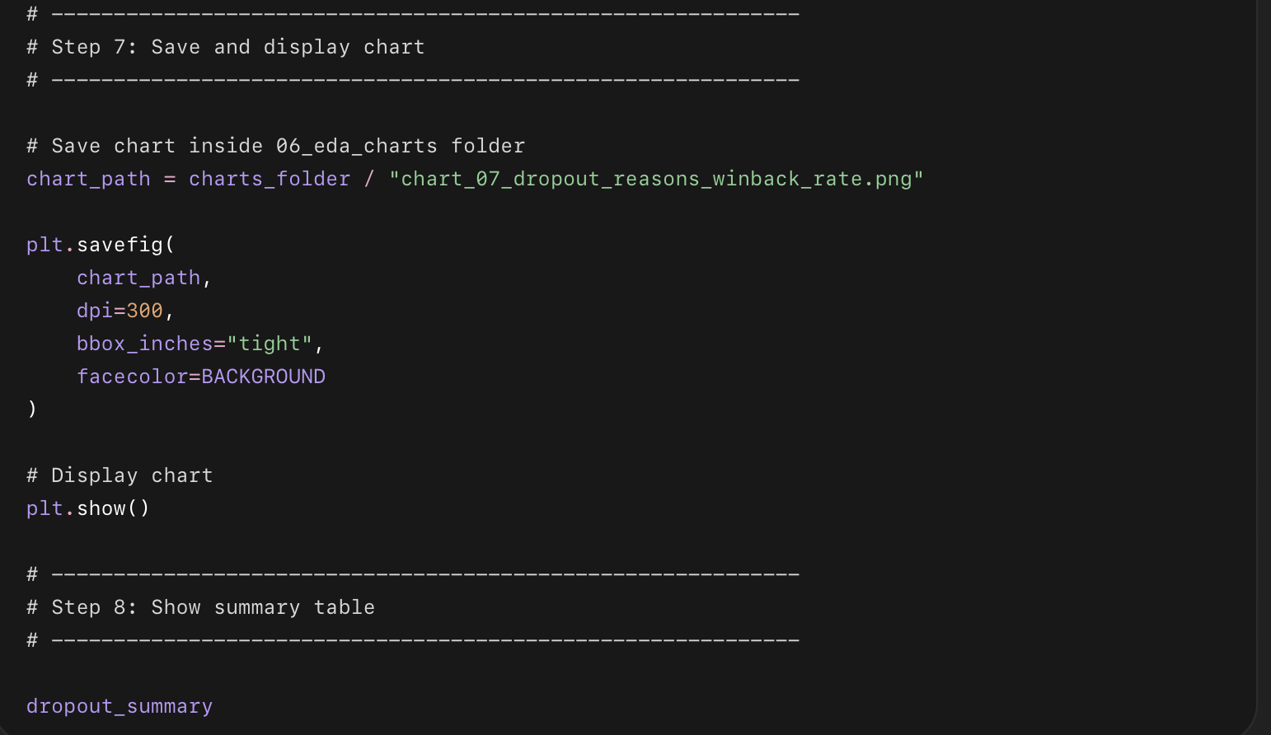

What this code does in simple points
- Filters only clients who dropped out.
- Groups them by Dropout_Reason.
- Counts how many clients dropped for each reason.
- Counts how many came back after dropping.
- Calculates the win-back rate for each reason.
- Creates a red bar chart for dropout count.
- Adds a green line showing win-back rate.
- Saves the chart as:
06_eda_charts/chart_07_dropout_reasons_winback_rate.png

Phase 3 — Chart 8: Check-in Rate vs Goal Achievement
This chart answers:
Does higher engagement lead to better client success?
This is one of the most important charts in the whole project because it connects client behavior to business outcome.
We will convert Goal_Achieved into a numeric score:
No = 0
Partial = 0.5
Yes = 1
Ongoing = removed from this chart
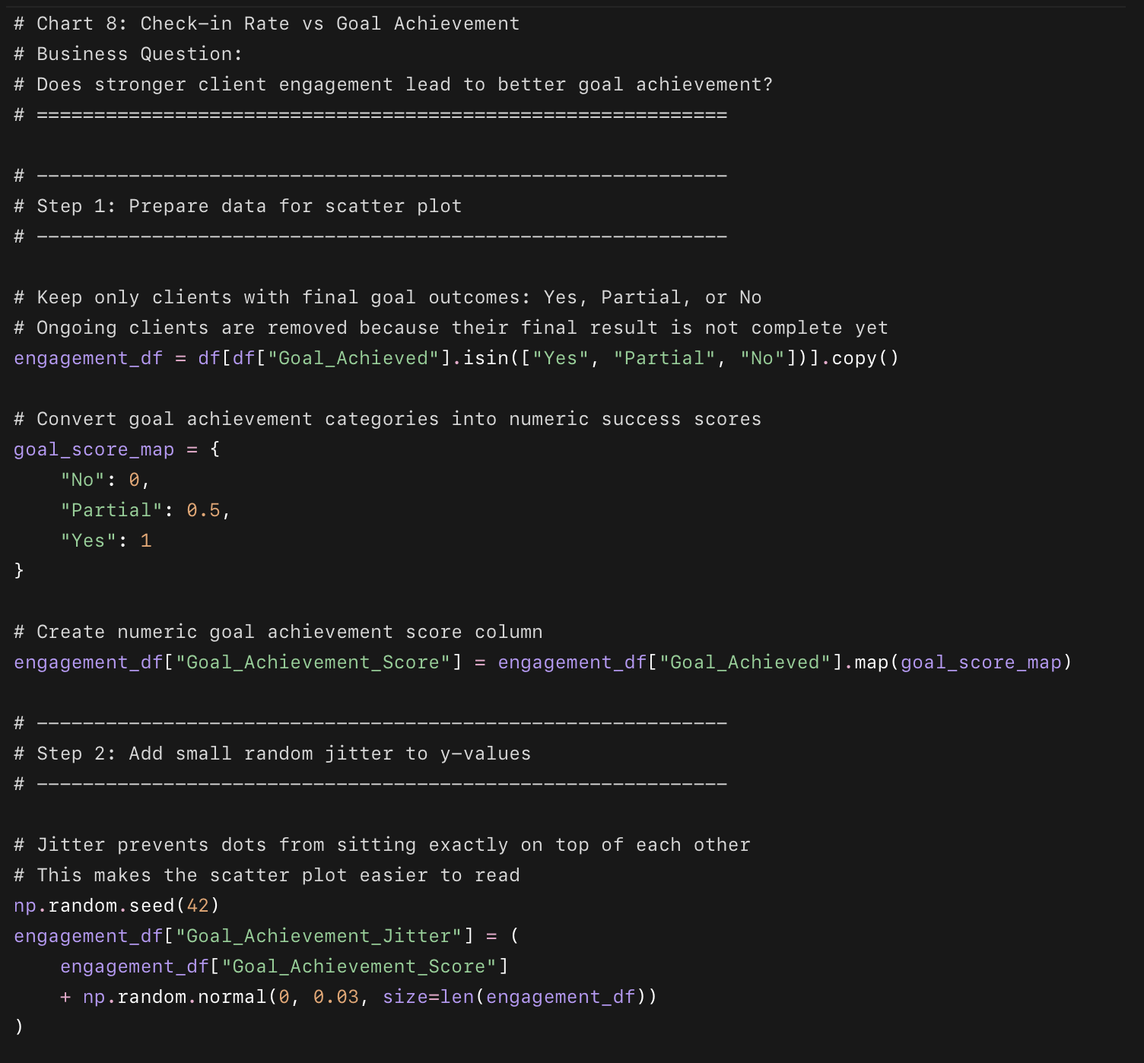
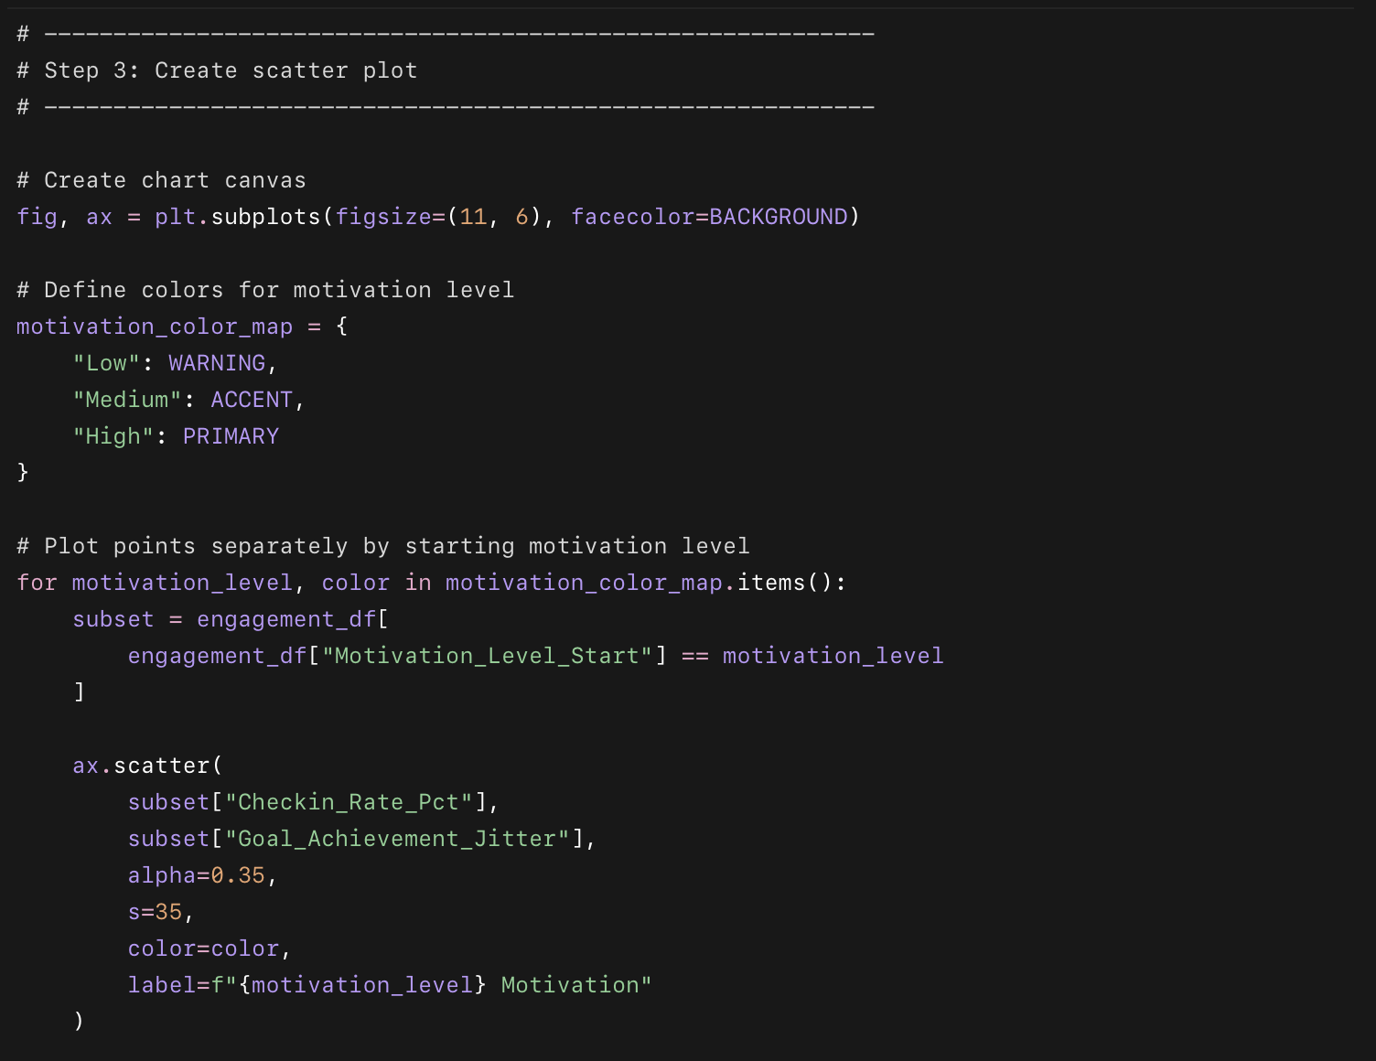
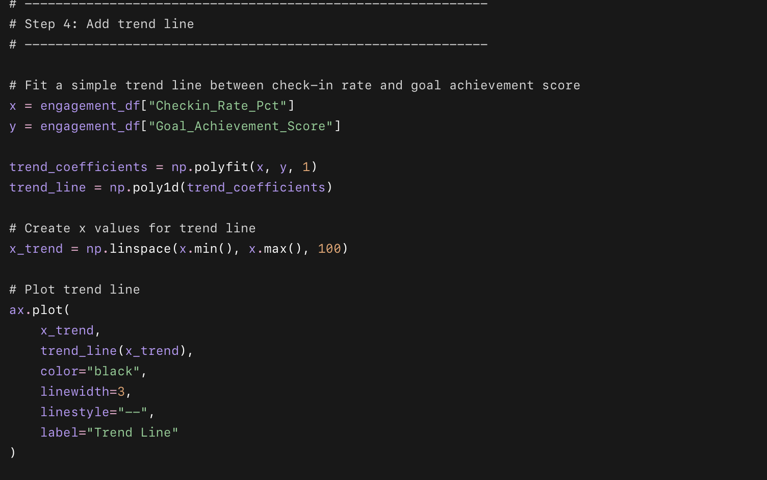
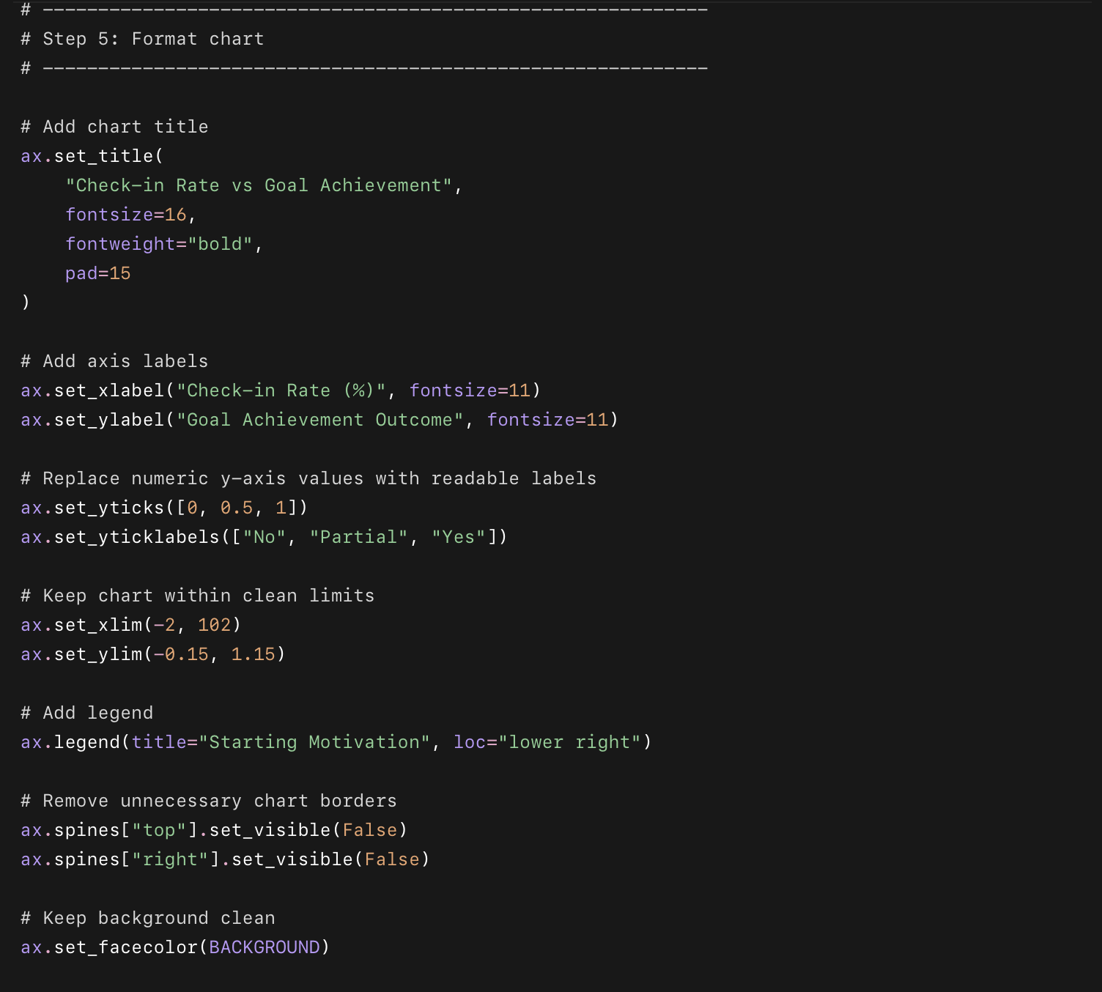
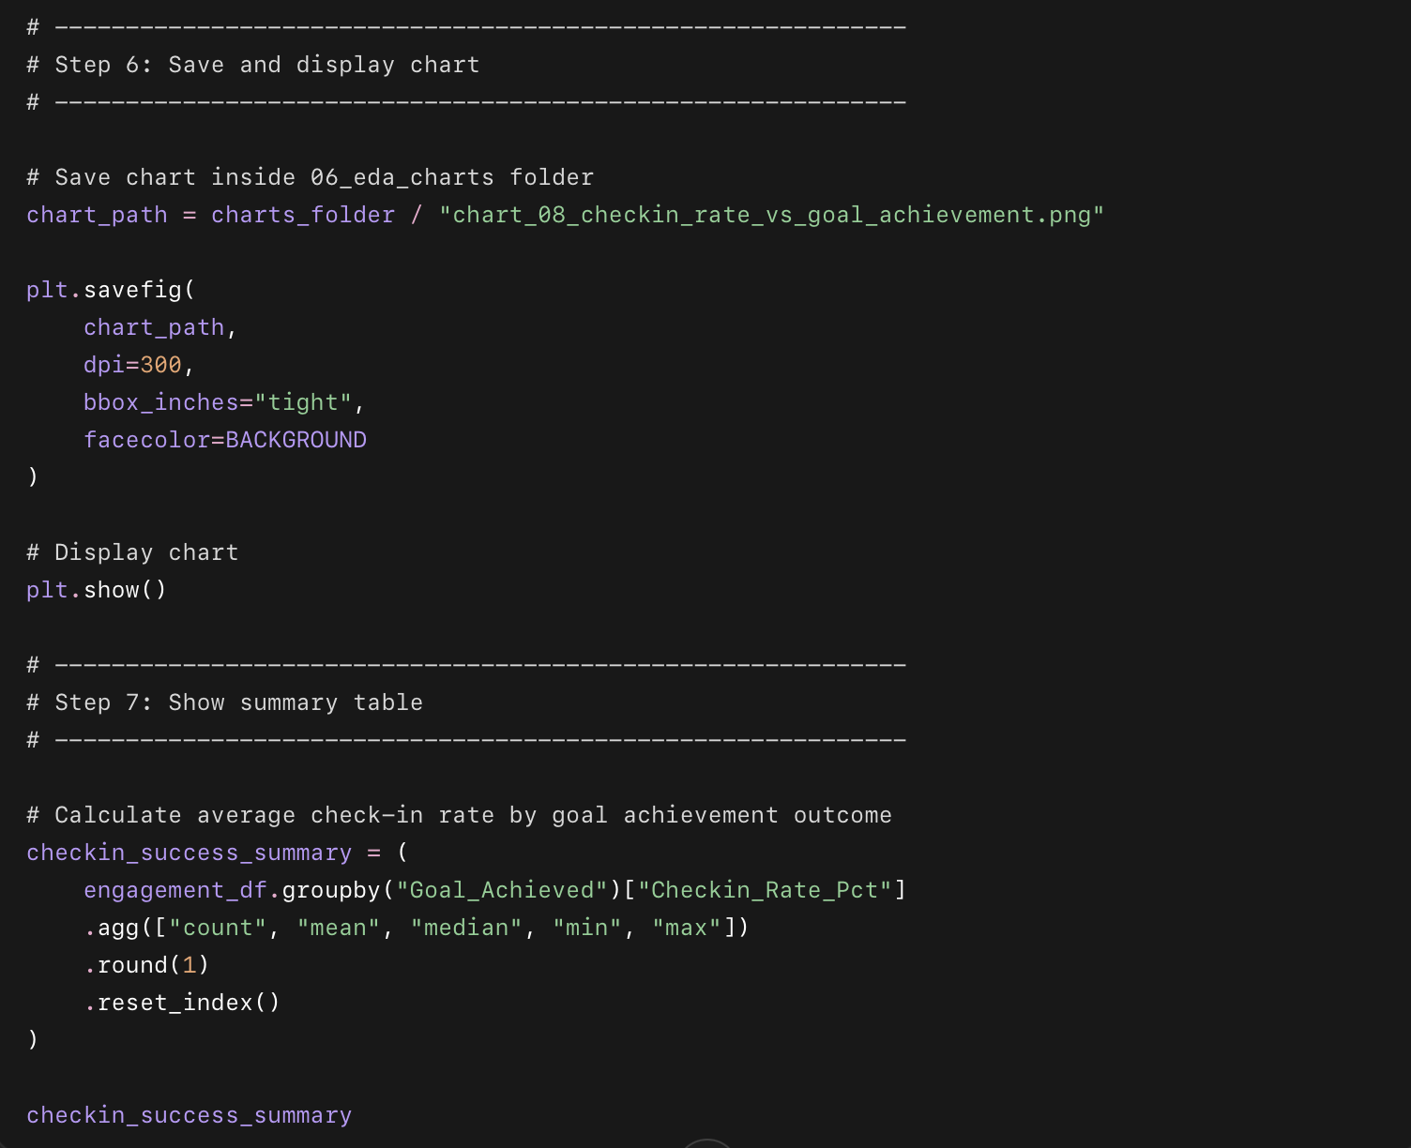

What this code does in short points
- Removes Ongoing clients because their final result is not confirmed yet.
- Converts goal achievement into a score:
  - No = 0
  - Partial = 0.5
  - Yes = 1
- Creates a scatter plot of:
  - X-axis: Checkin_Rate_Pct
  - Y-axis: goal achievement score
- Colors each dot by starting motivation level.
- Adds small jitter so dots do not overlap too much.
- Adds a trend line to show the relationship.
- Saves the chart as:
06_eda_charts/chart_08_checkin_rate_vs_goal_achievement.png

Chart 9: Health Condition vs No Health Condition
This chart answers:
Are clients with health conditions less successful, or are they performing equally well?
We will compare two groups:
Has Health Condition
No Health Condition
And compare them by:
Completion Rate
Goal Achievement Rate

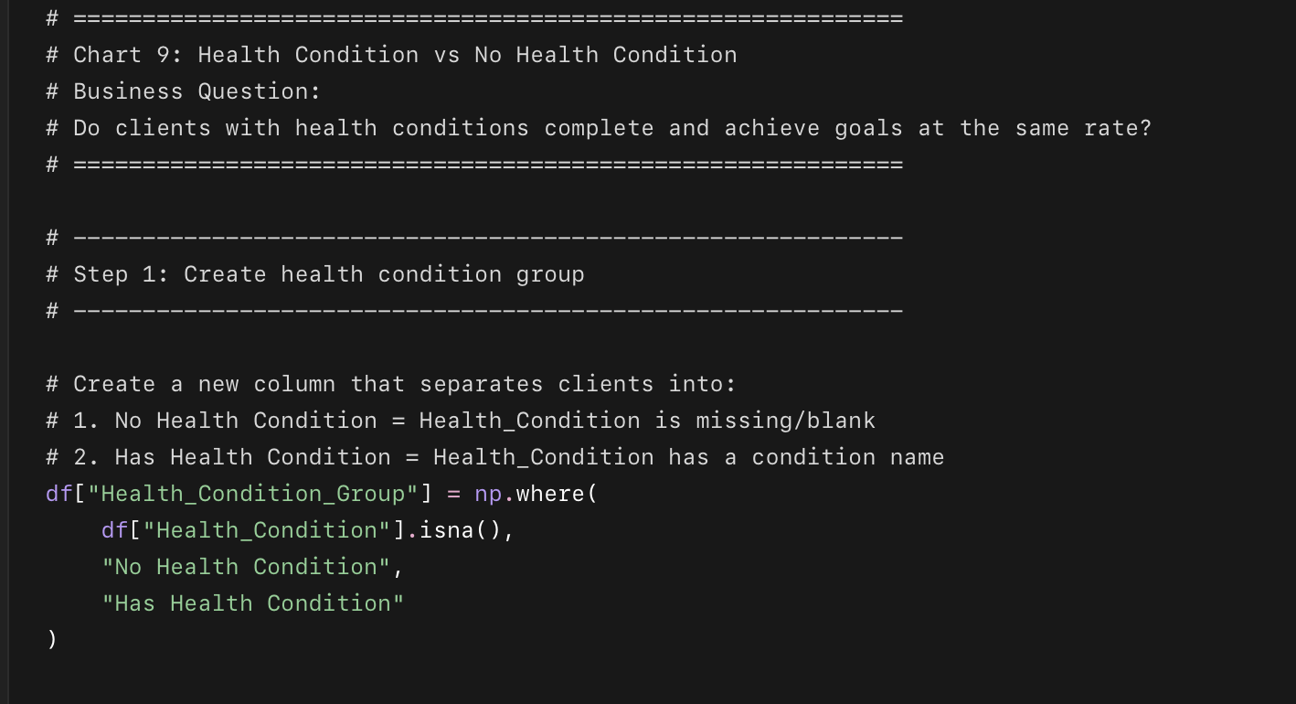
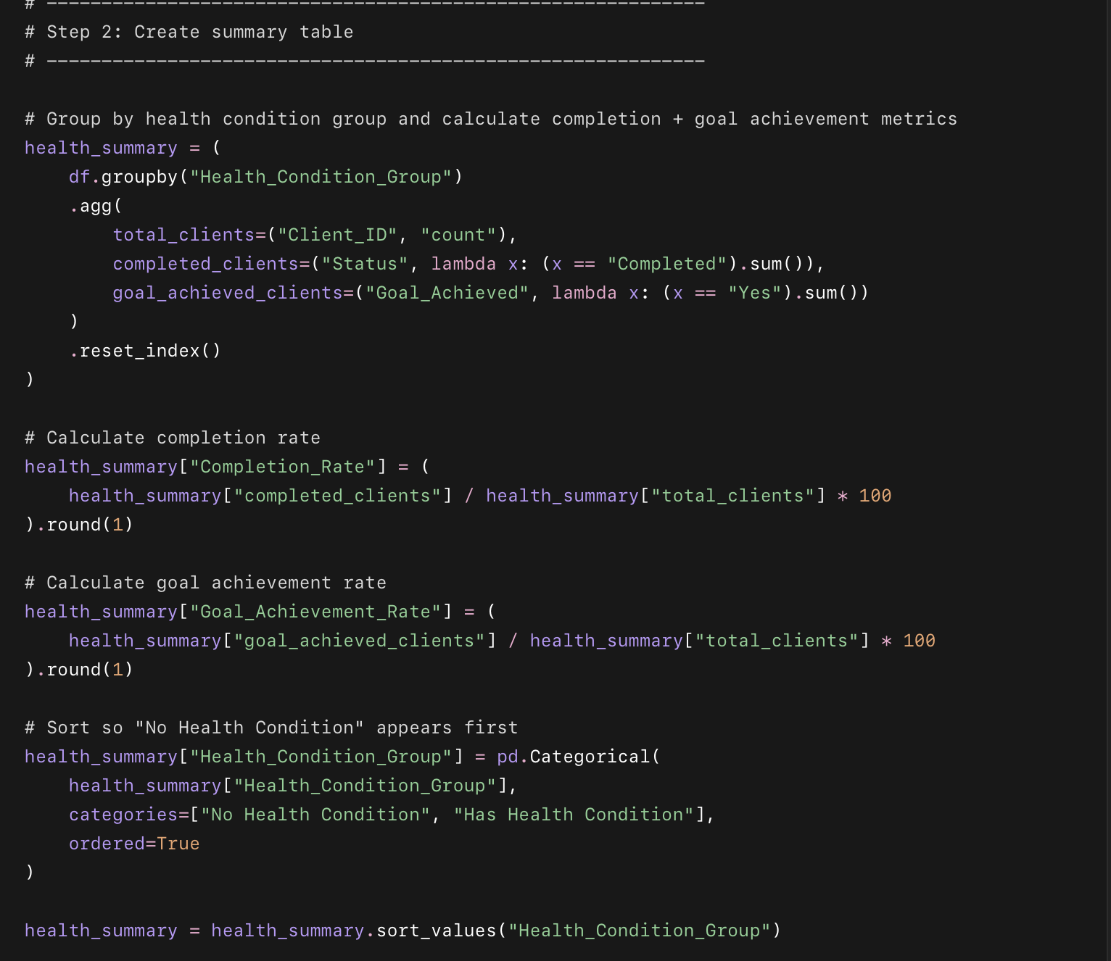
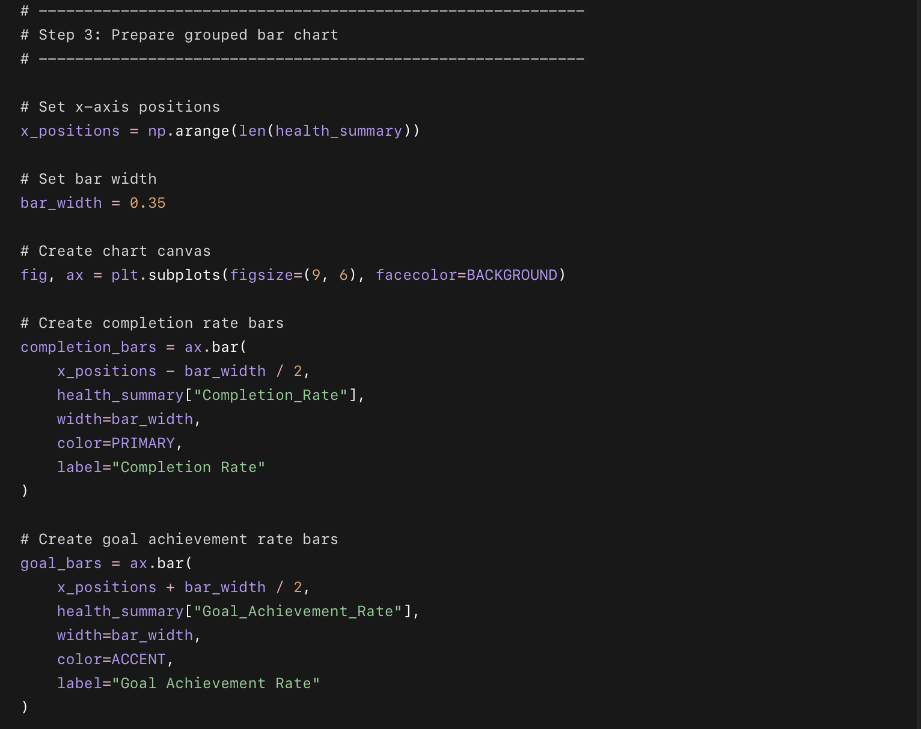
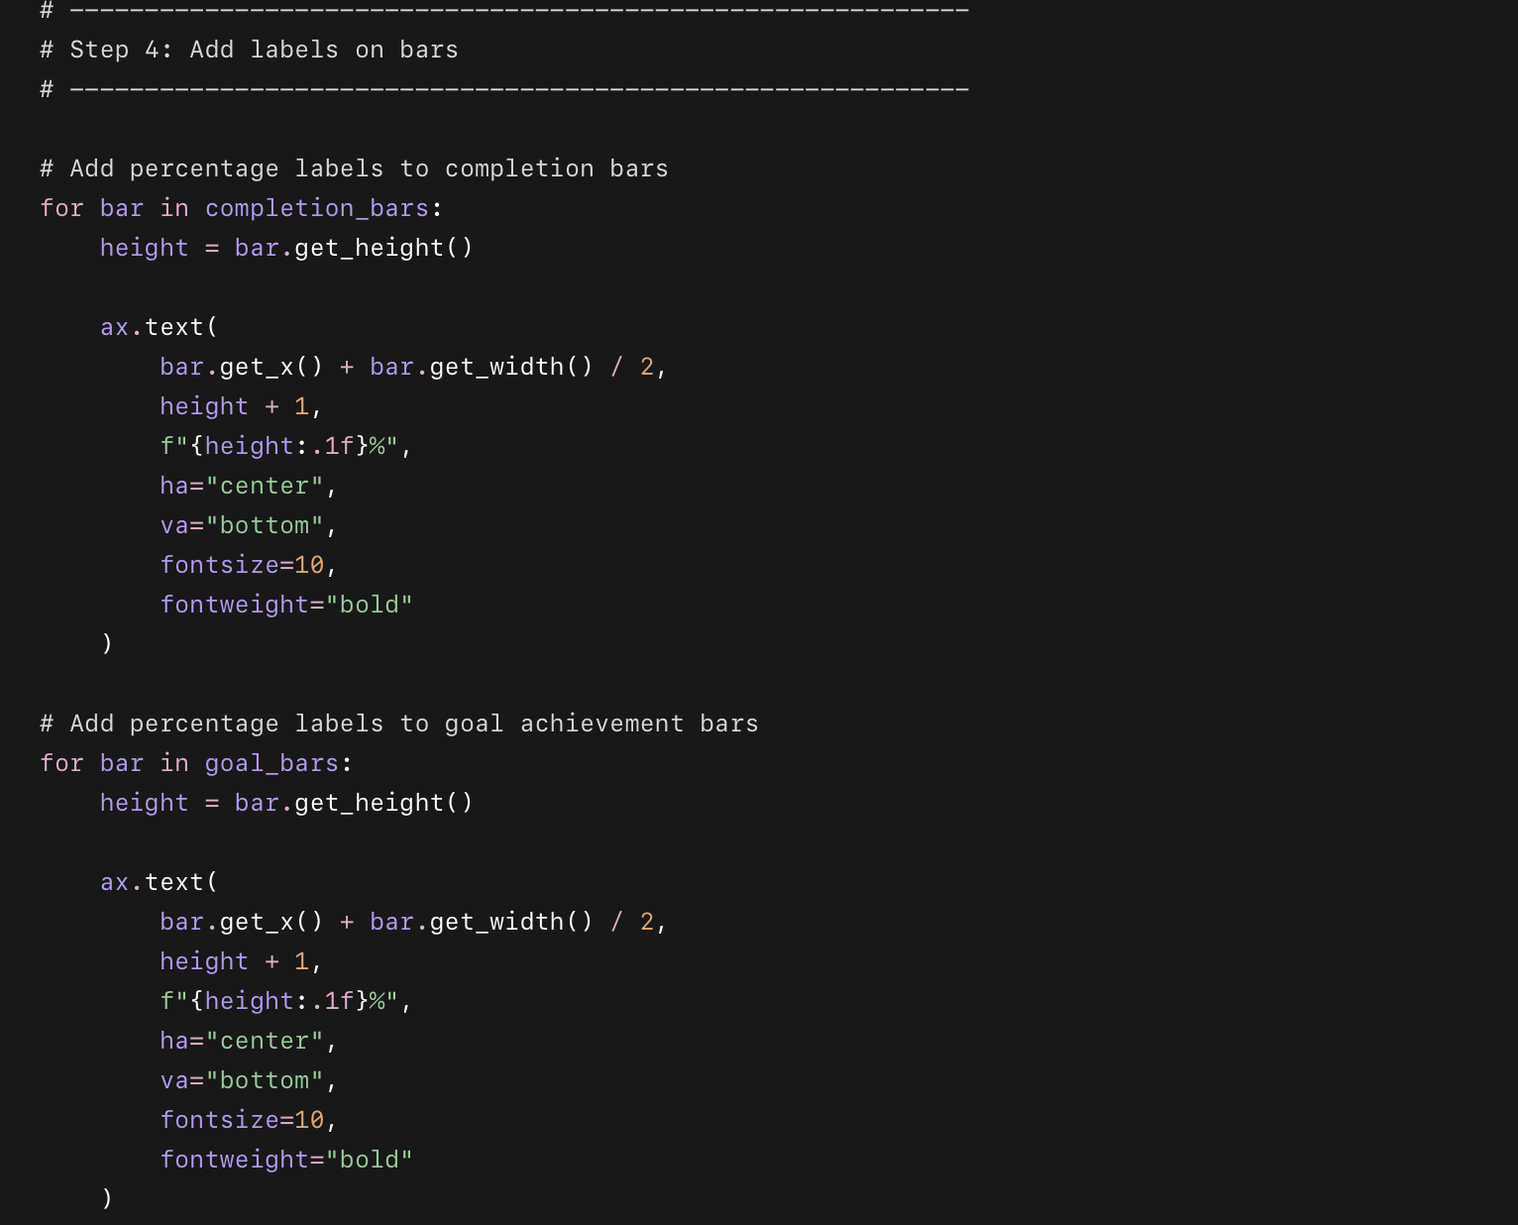
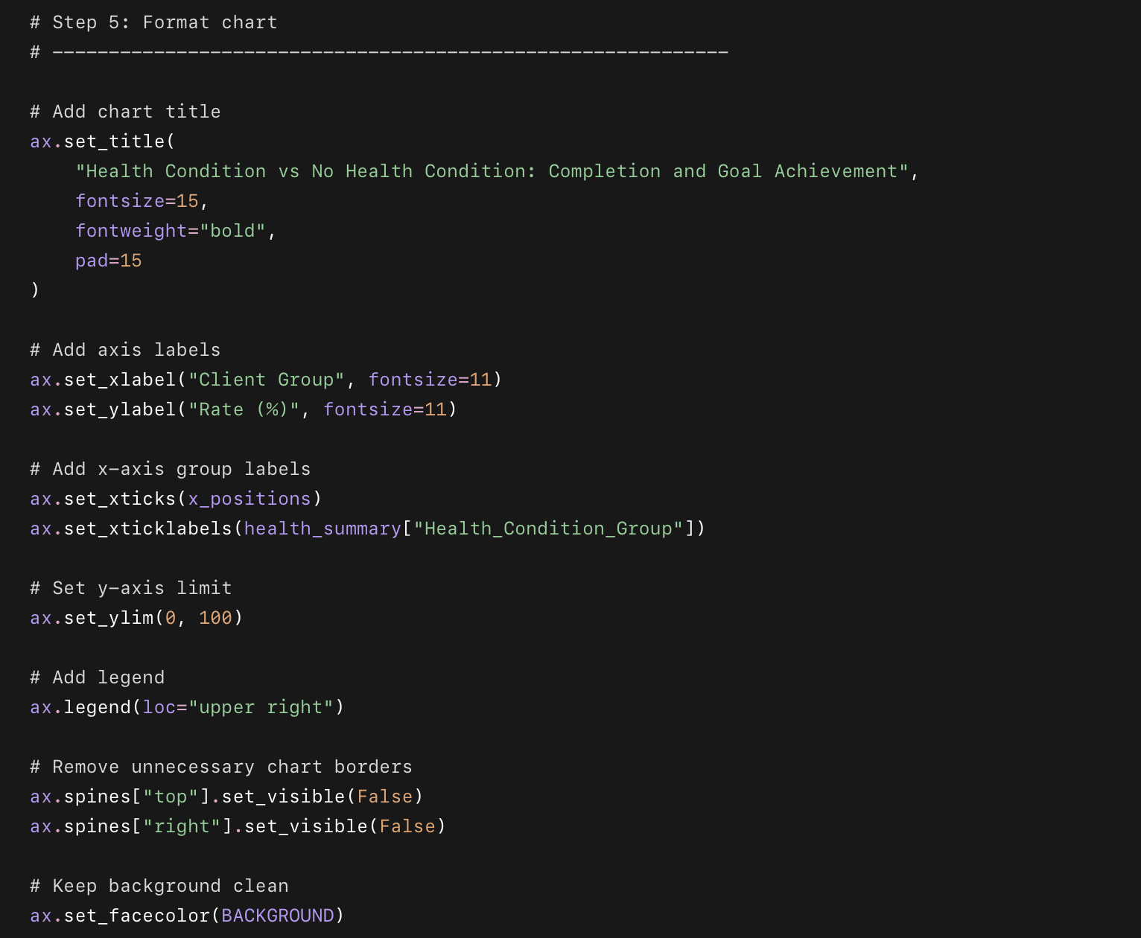
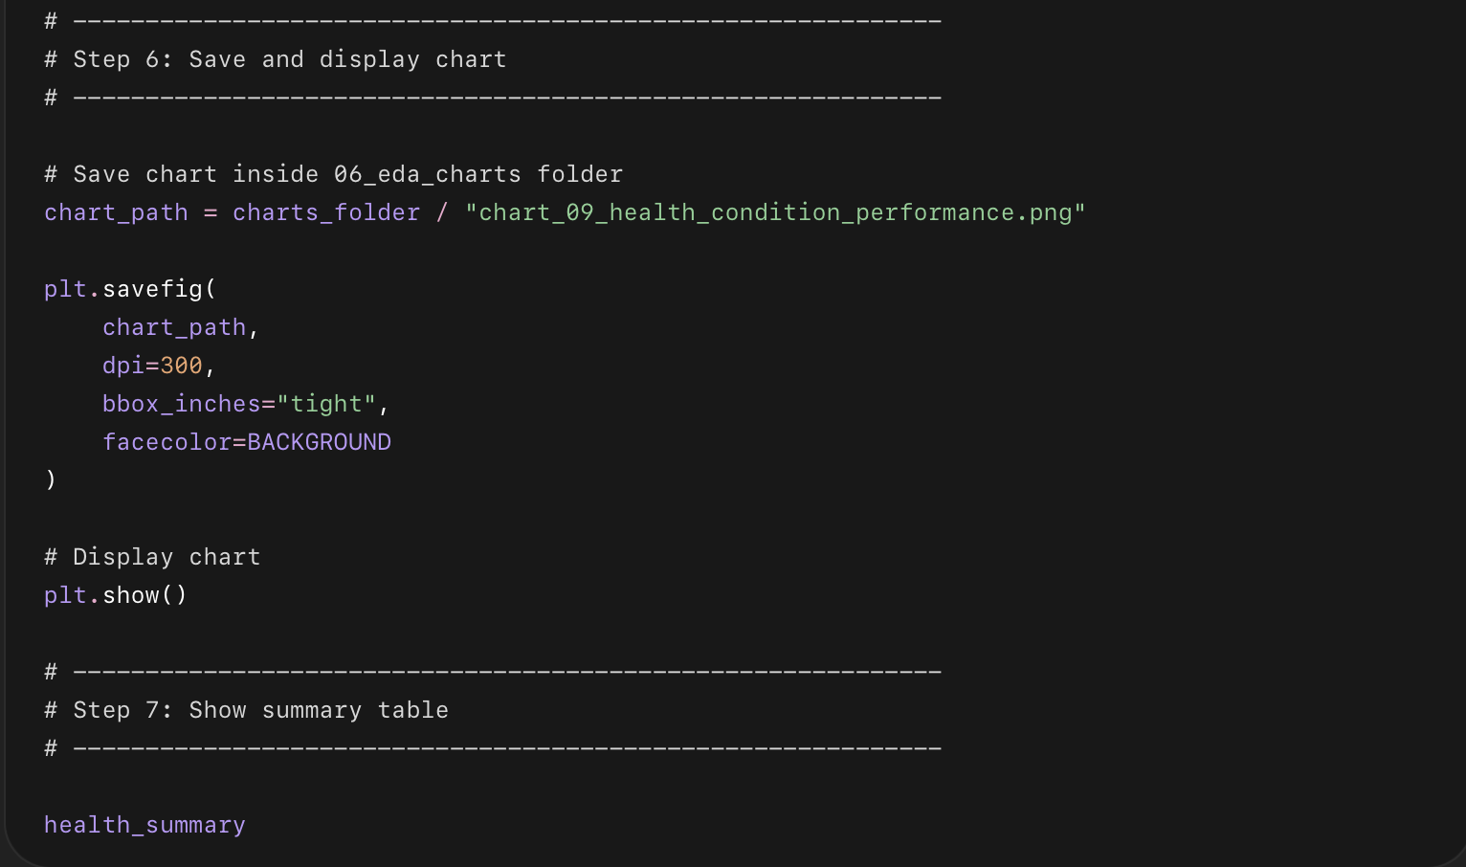

What this code does in short points
- Creates a new column called Health_Condition_Group.
- Puts clients into:
  - Has Health Condition
  - No Health Condition
- Counts total clients in both groups.
- Counts completed clients in both groups.
- Counts goal-achieved clients in both groups.
- Calculates:
  - Completion rate
  - Goal achievement rate
- Creates a side-by-side bar chart.
- Adds percentage labels on each bar.
- If Health_Condition is blank, label the client as No Health Condition.
- df["Health_Condition"].isna() tell python If Health_Condition has PCOS, Thyroid, Back Pain, Diabetes, or Other, label the client as Has Health Condition.
- Saves the chart as:
06_eda_charts/chart_09_health_condition_performance.png

Chart 10: Monthly New Clients by Lead Source
This chart answers:
Is client growth coming mainly from TikTok, Instagram, referrals, or other sources — and is it growing over time?
We will create a stacked monthly bar chart using:
Payment_Date × Lead_Source

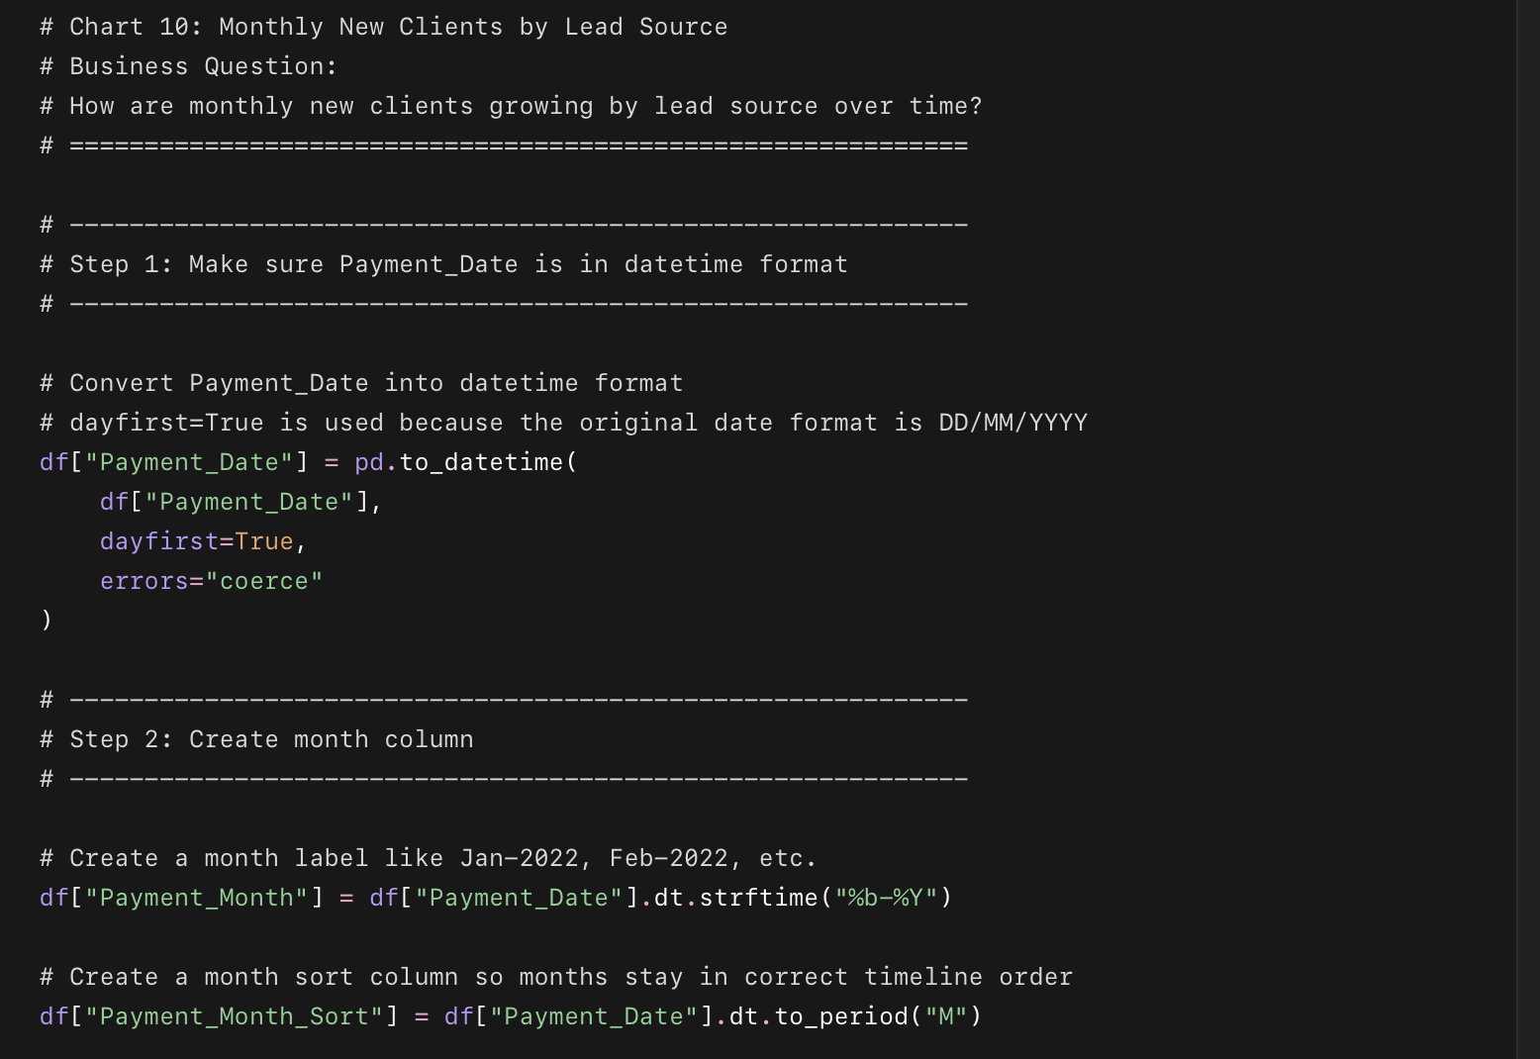
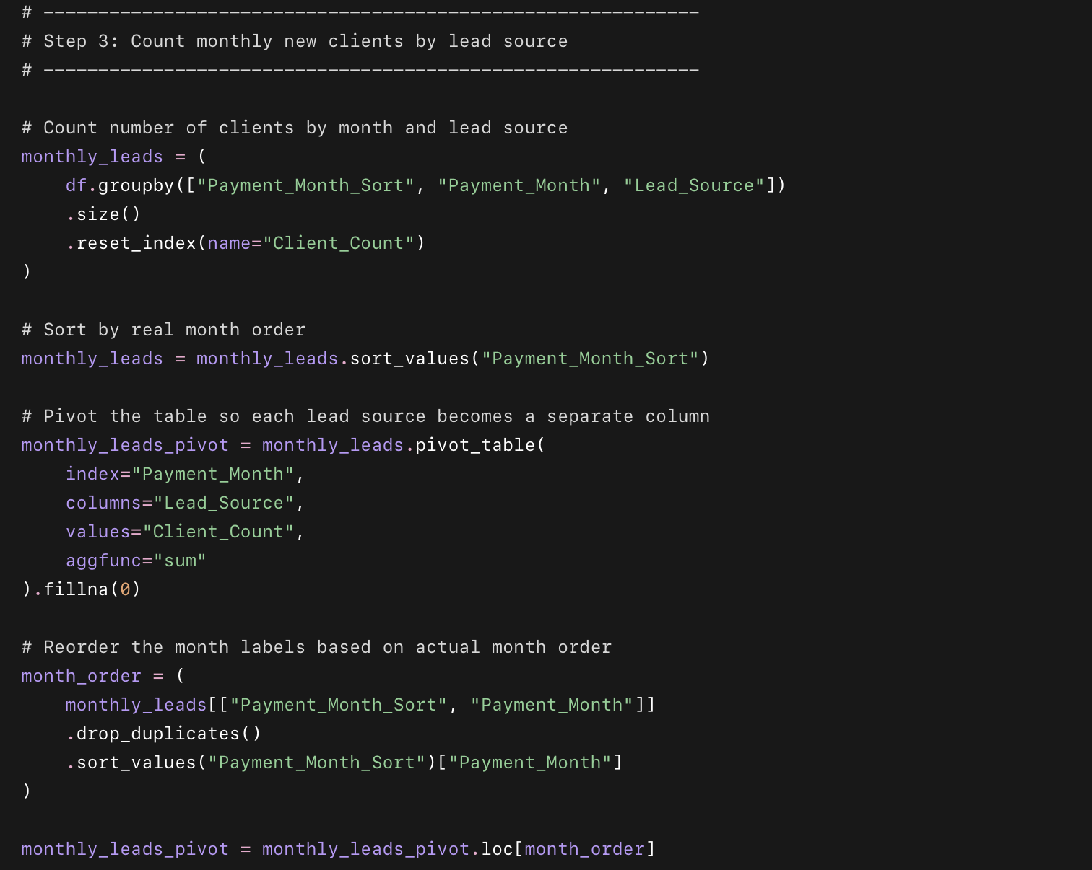
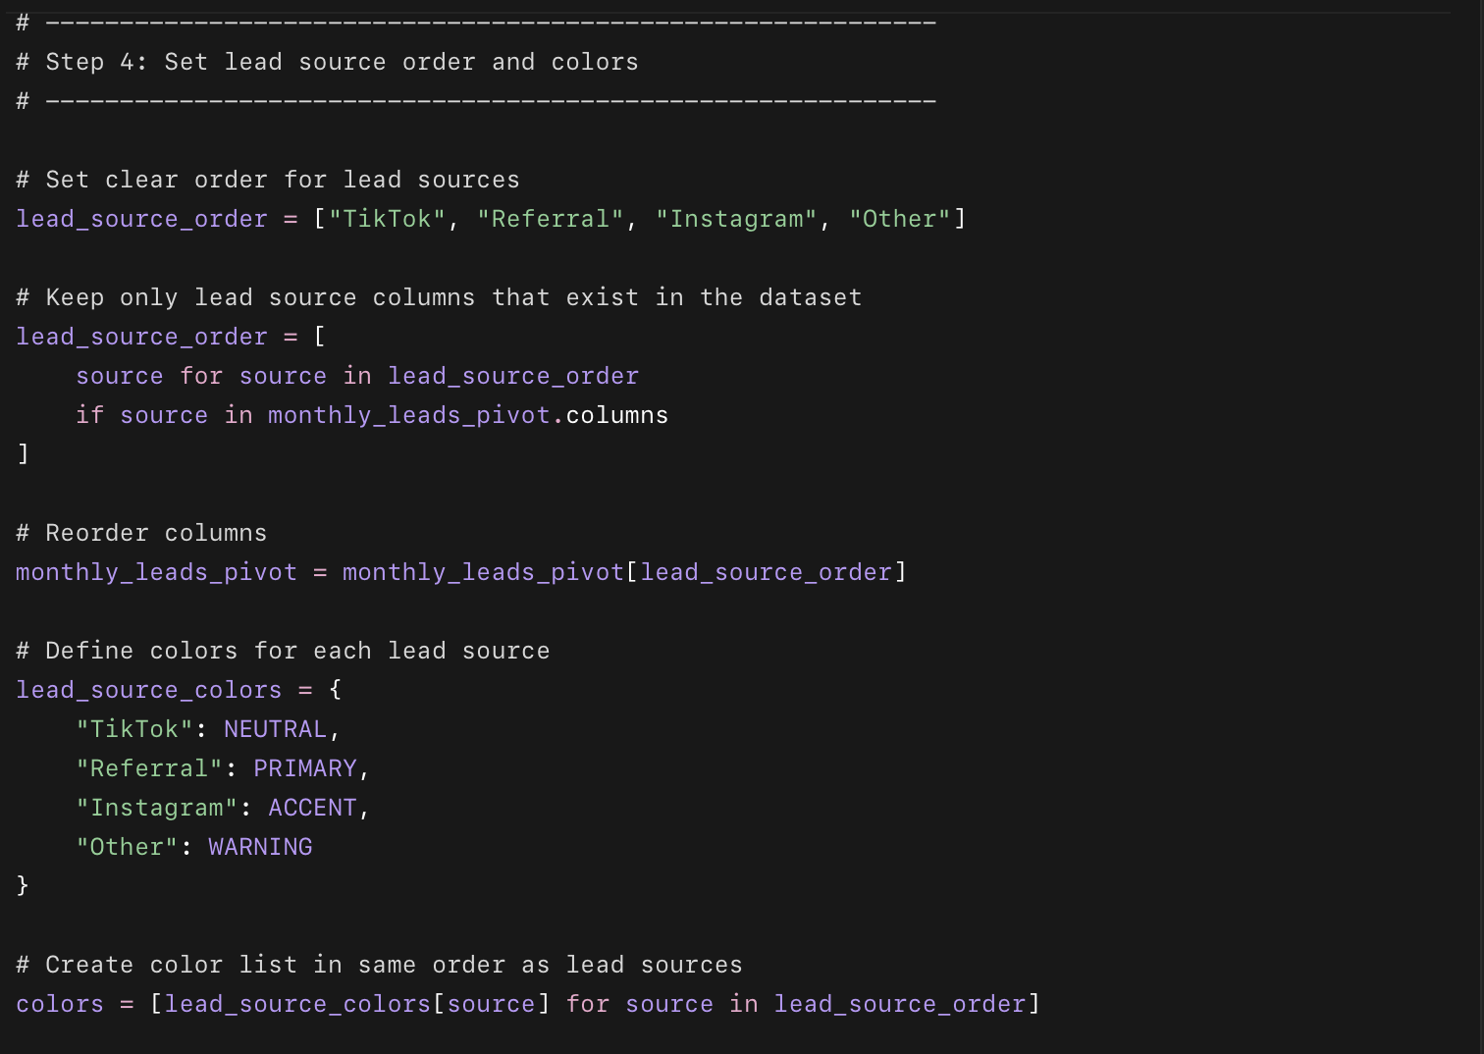

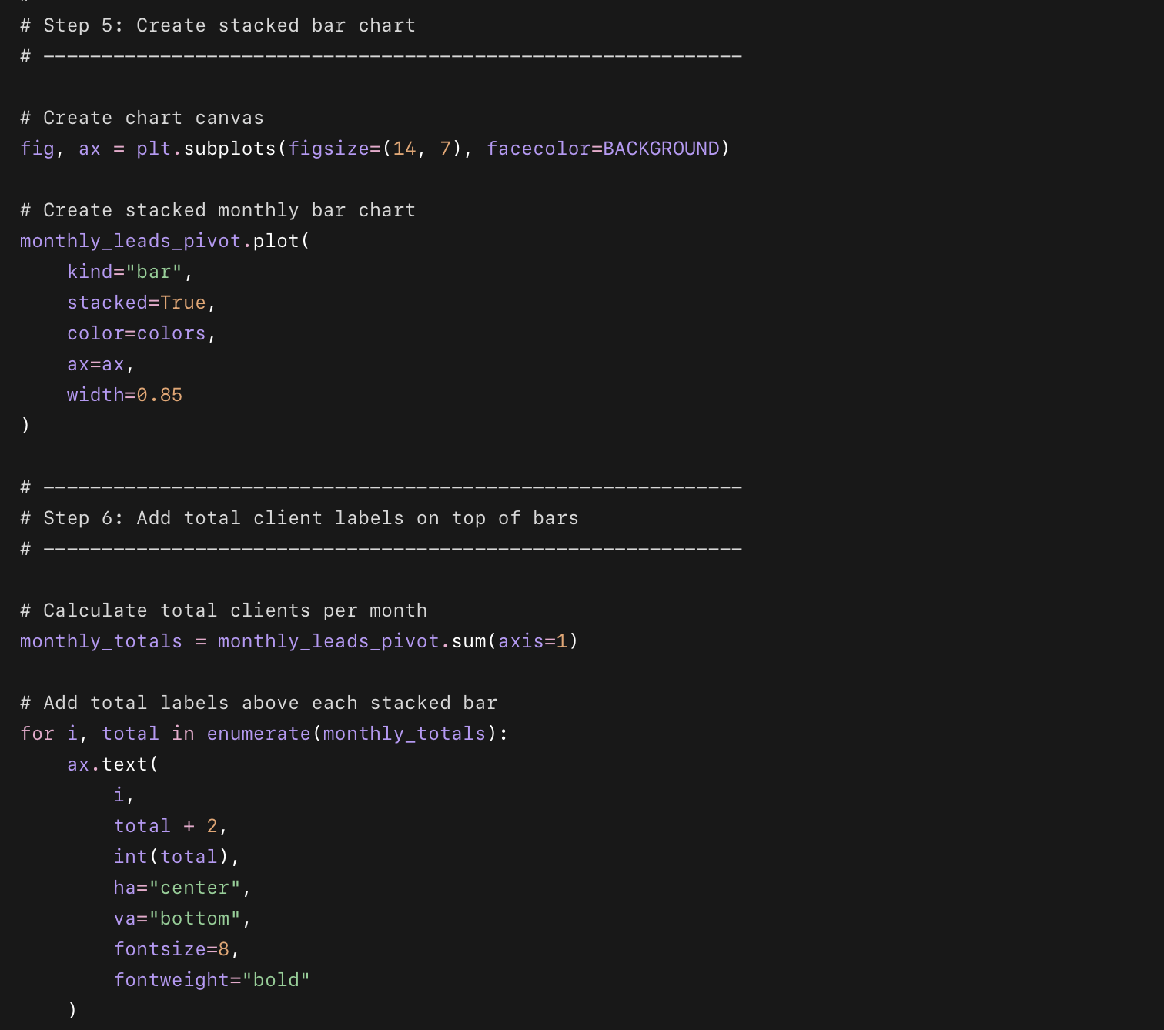
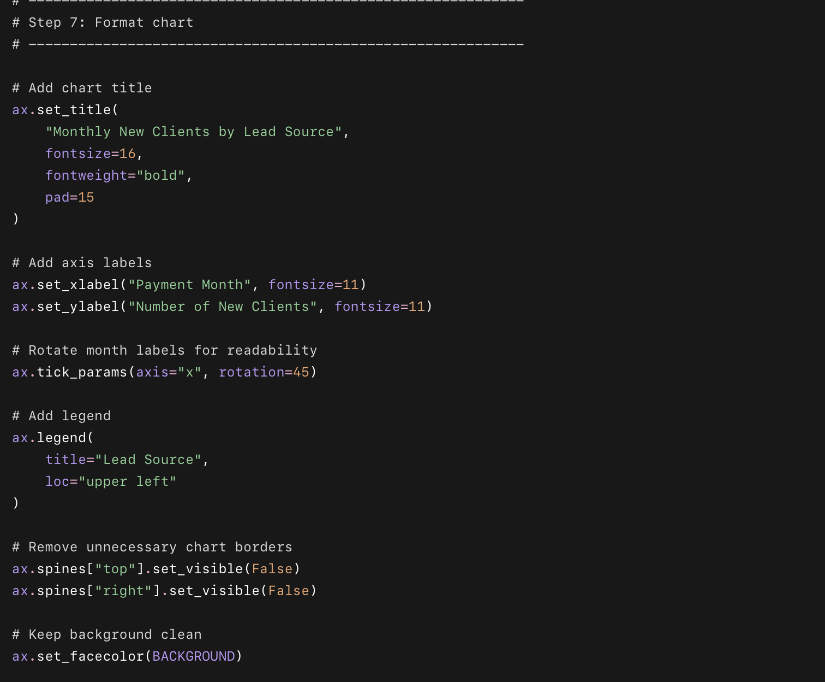
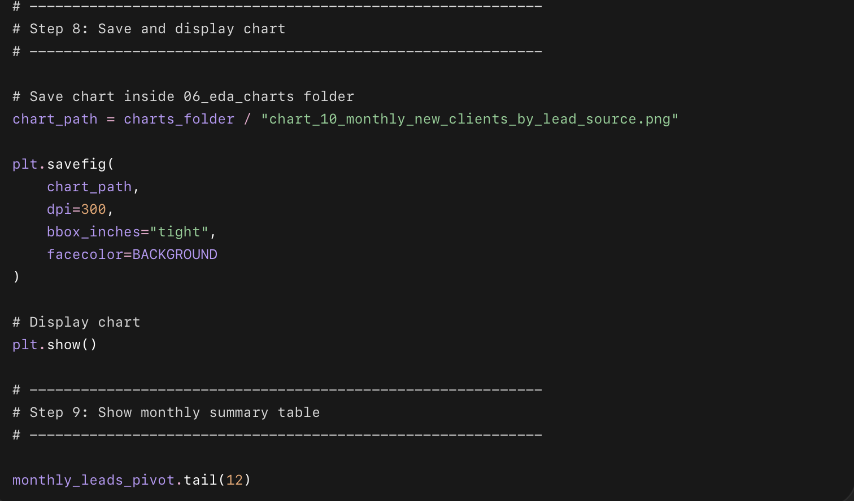

What Chart 10 code does — very short points
- Converts Payment_Date into a real date.
- Creates a monthly label like Jan-2024.
- Counts how many new clients joined each month.
- Splits monthly clients by lead source:
  - TikTok
  - Referral
  - Instagram
  - Other
- Creates a stacked bar chart to show monthly growth.
- Adds total client count above each month.
- Saves the chart inside:
06_eda_charts/chart_10_monthly_new_clients_by_lead_source.png

What question this chart answers
Which lead sources are driving monthly client growth over time?

Chart 11: Second Round Clients vs Non-Second Round Clients
This chart answers:
What makes clients come back for another round?
We will compare clients who signed up for a second round vs those who did not using 4 metrics:
Average Check-in Rate
Goal Achievement Rate
Average Age
Referral Rate

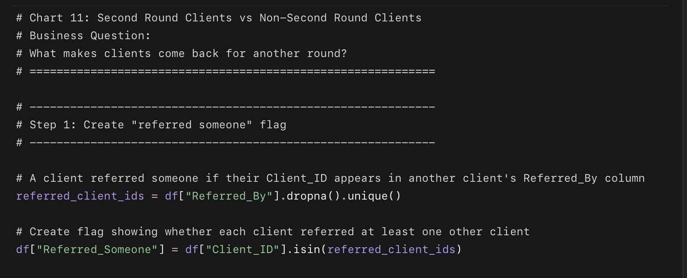
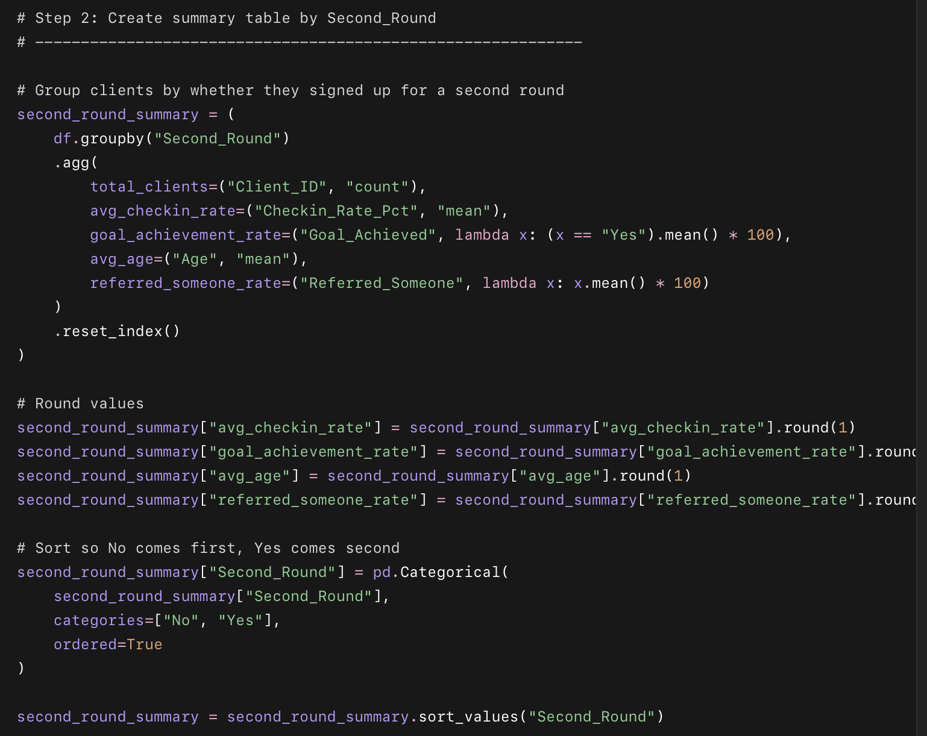
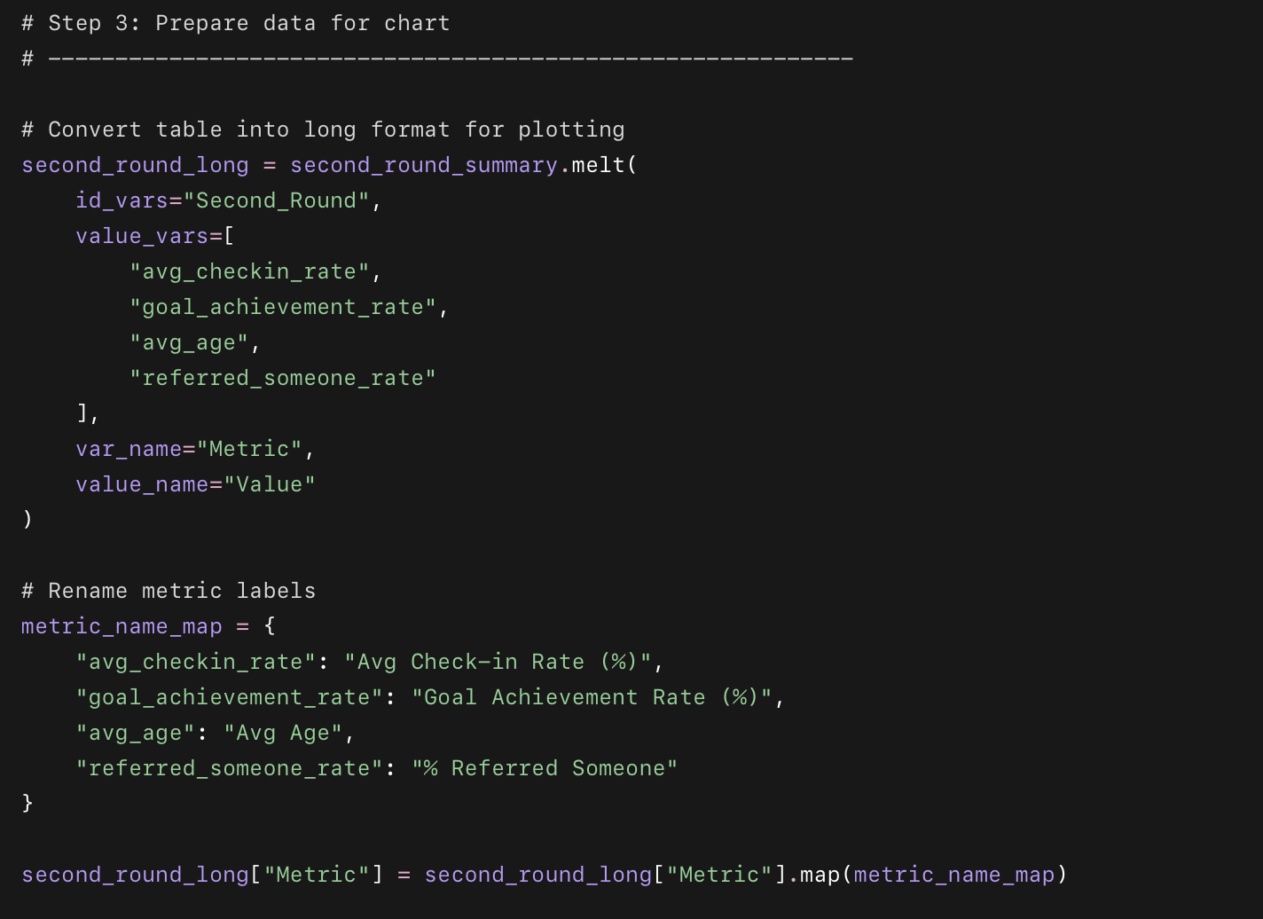
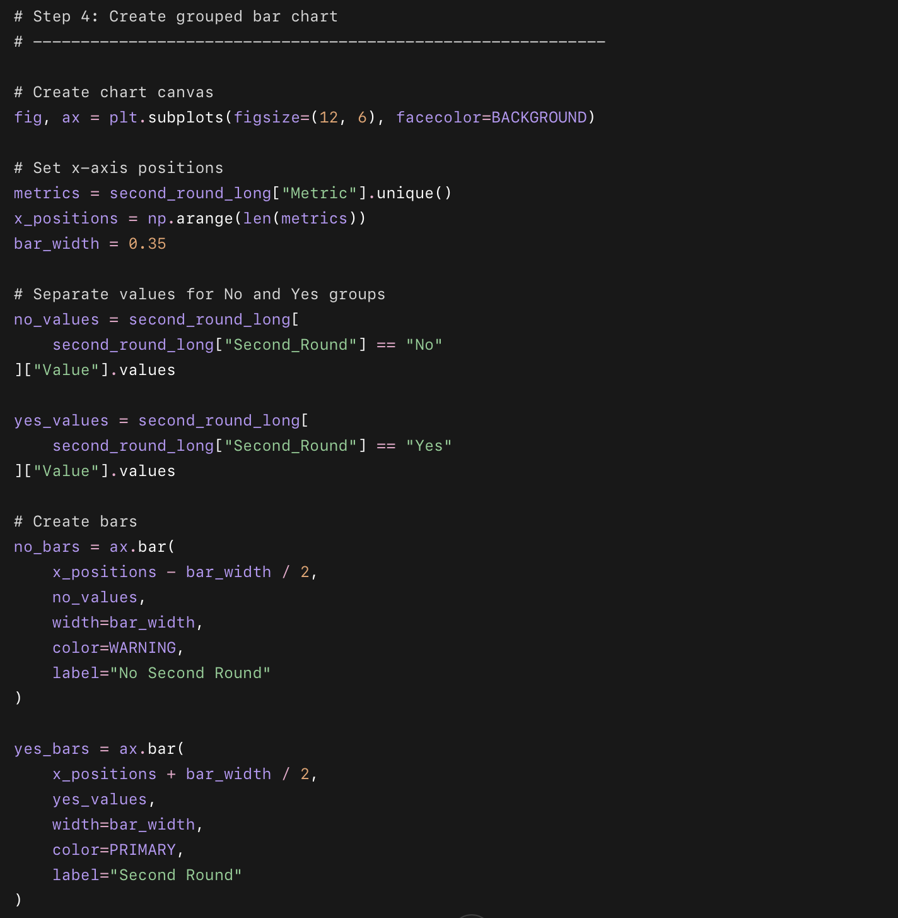
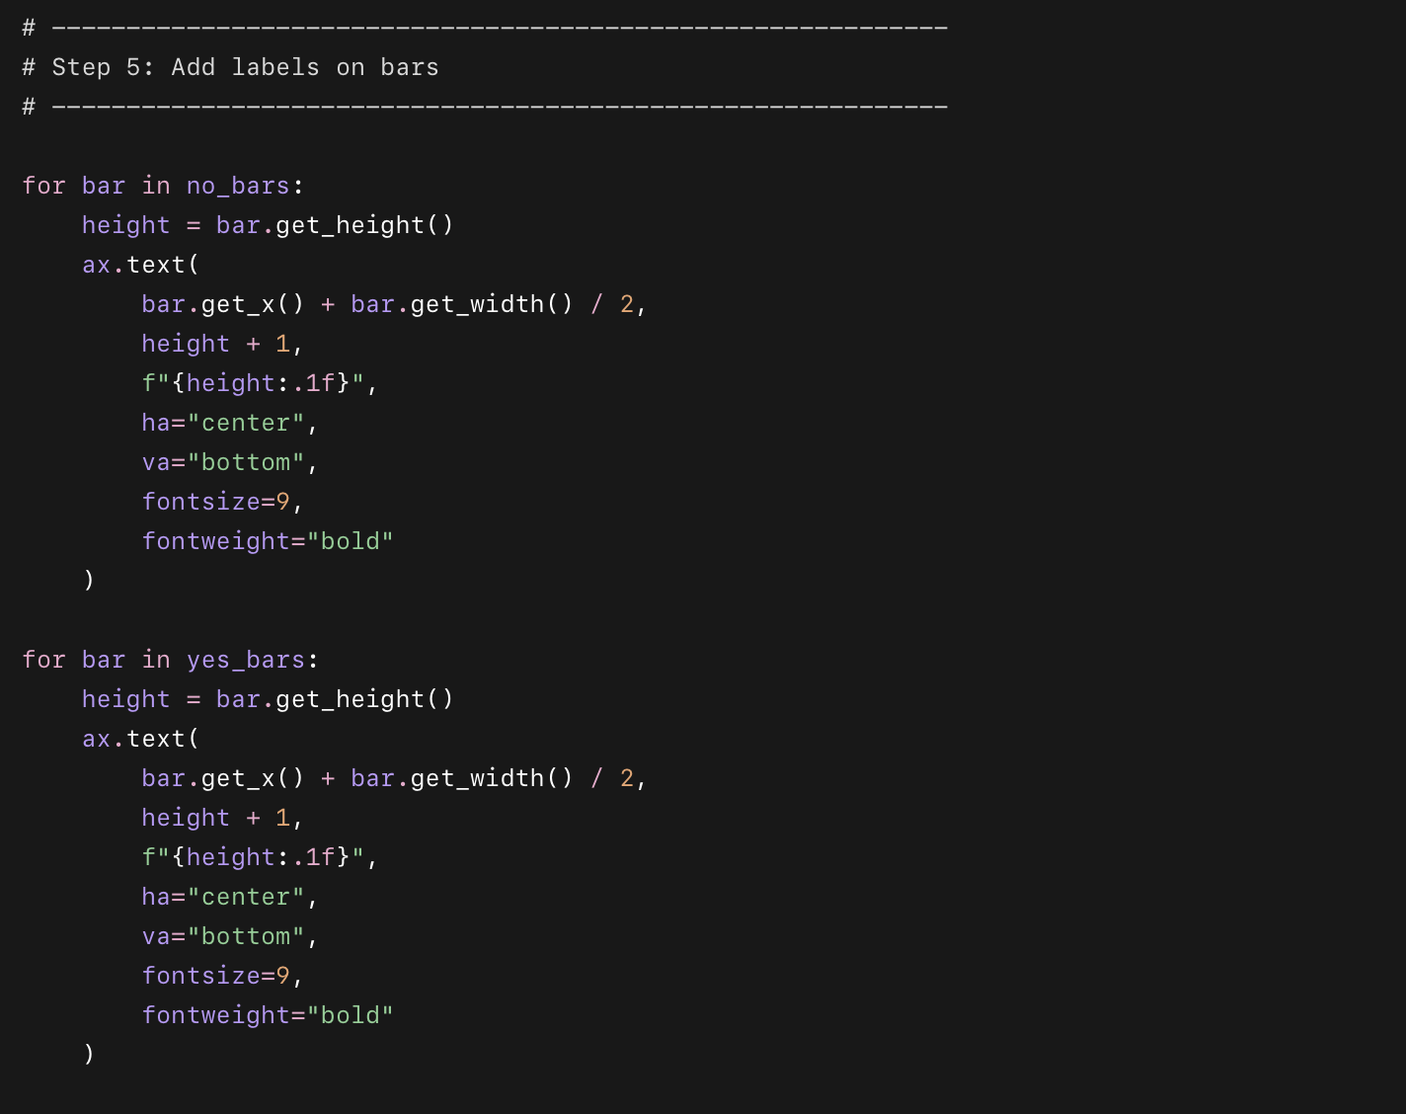
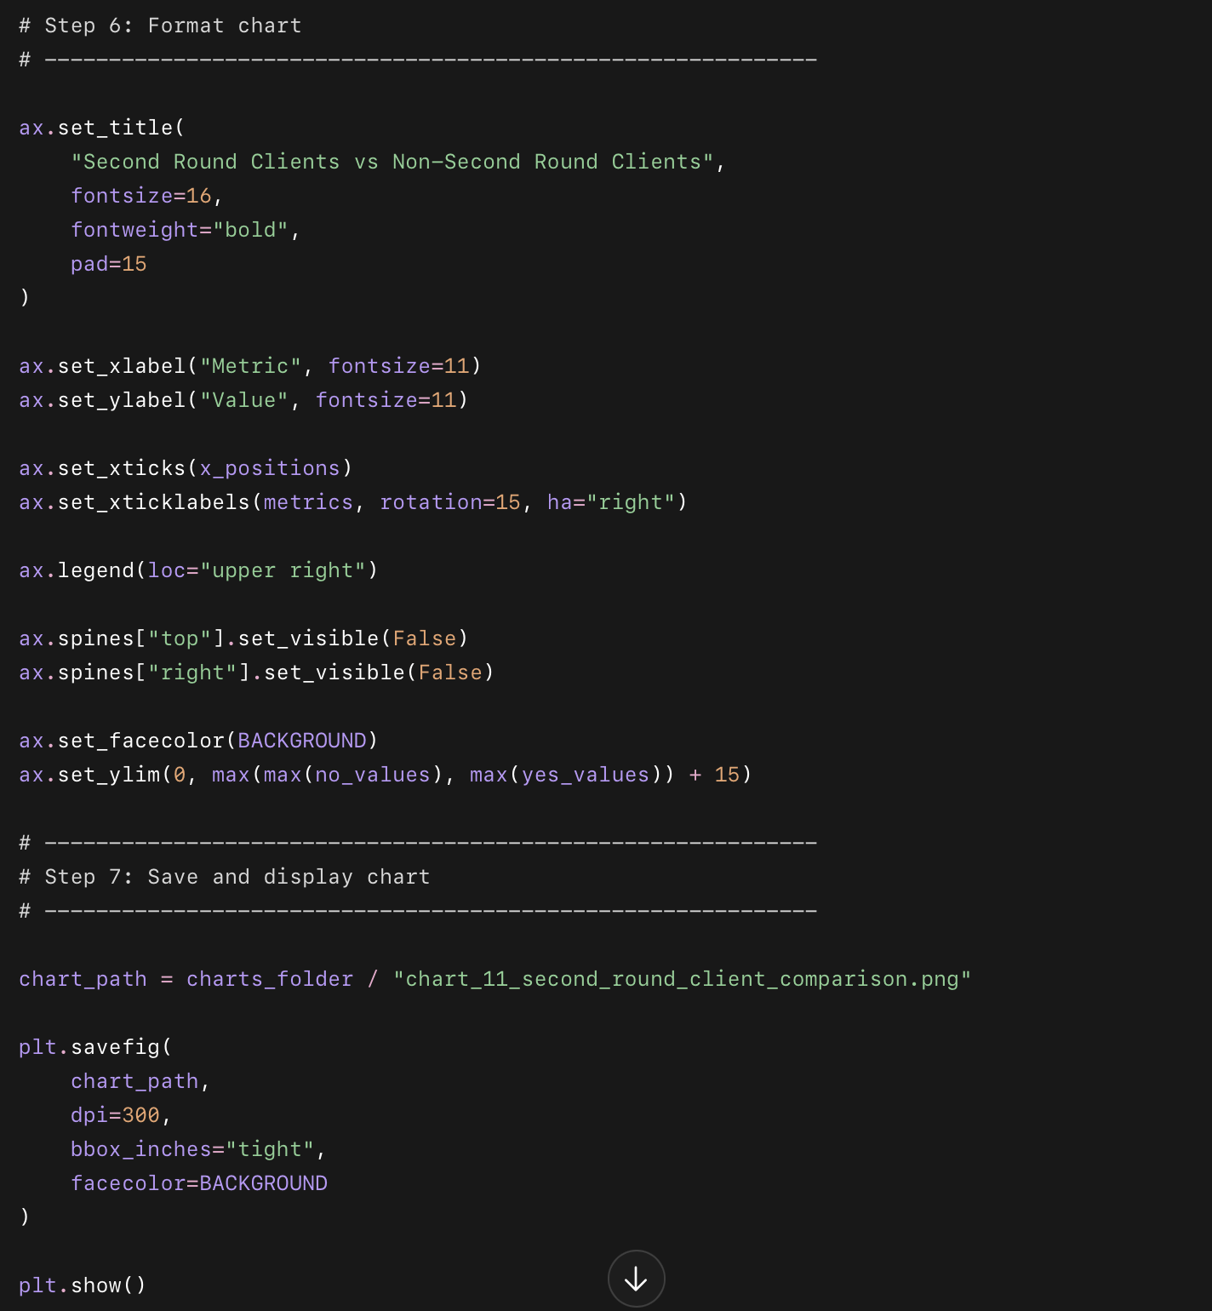
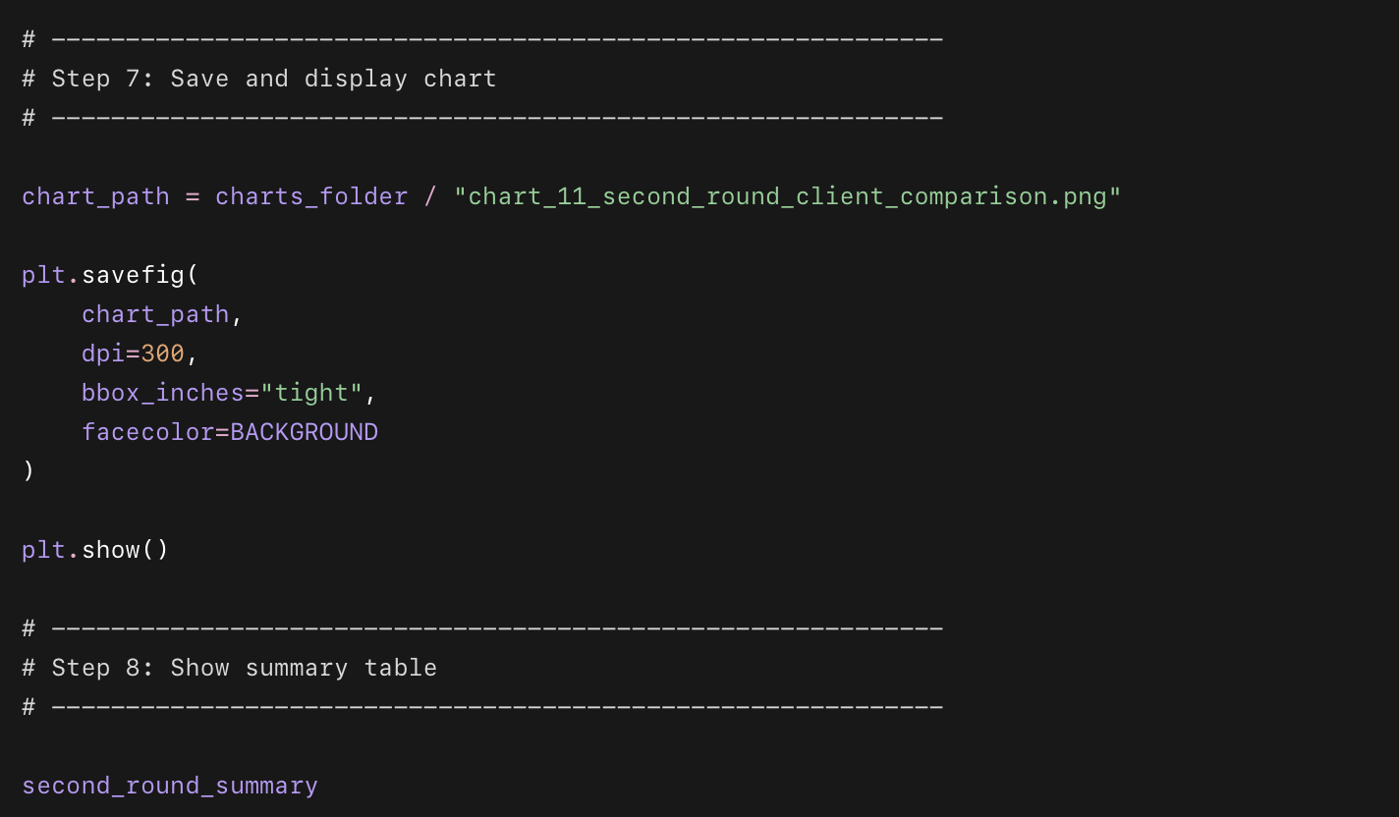

What Chart 11 code does — short points
- Finds clients who referred someone
  - It checks whether a client’s Client_ID appears in the Referred_By column.
- Creates a new column
  - Referred_Someone = True/False
- Splits clients into two groups
  - Second_Round = Yes
  - Second_Round = No
- Calculates 4 comparison metrics
  - Average check-in rate
  - Goal achievement rate
  - Average age
  - Percentage who referred someone
- Creates a side-by-side bar chart
  - Red bars = no second round
  - Green bars = second round
- Adds labels on bars
  - Shows exact values on top of each bar.
- Saves the chart
  - Saves it inside:
06_eda_charts/chart_11_second_round_client_comparison.png
- Shows a summary table
  - Displays the exact values used in the chart.

What question this chart answers
What makes clients come back for another round?

Are second-round clients more engaged, more successful, older, or more likely to refer someone?

Chart 12: Program Duration by Status
This chart answers:
Do clients who stay longer perform better, or do certain statuses show shorter/longer program patterns?
We will compare Program_Duration_Days across:
Completed
Ghost
Inactive
Quit

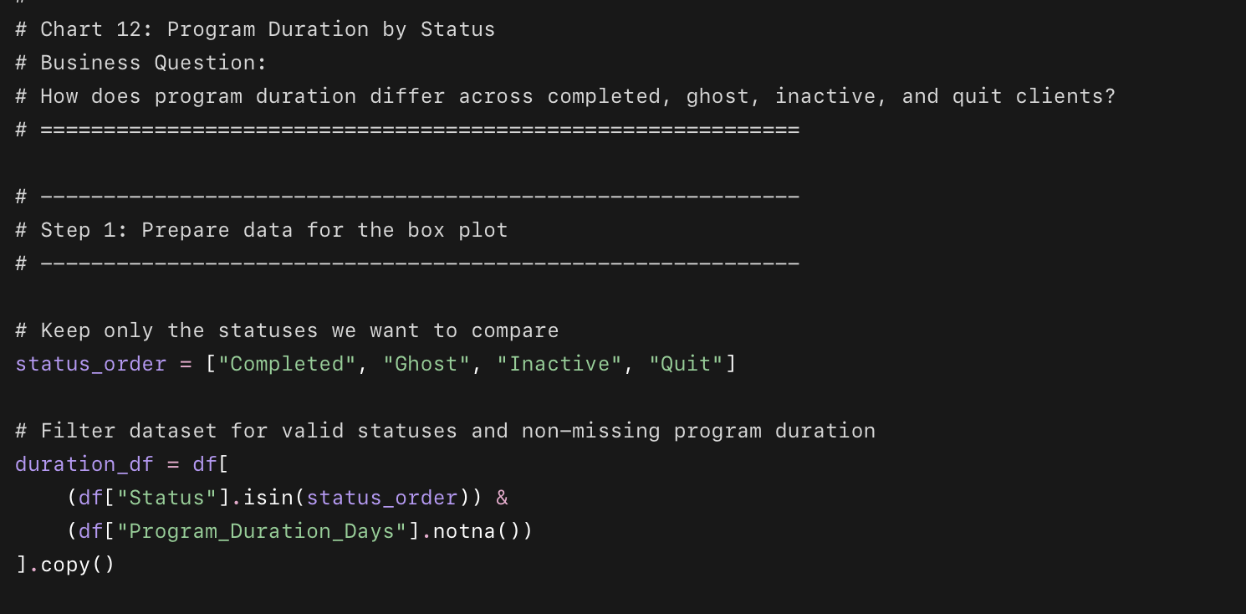
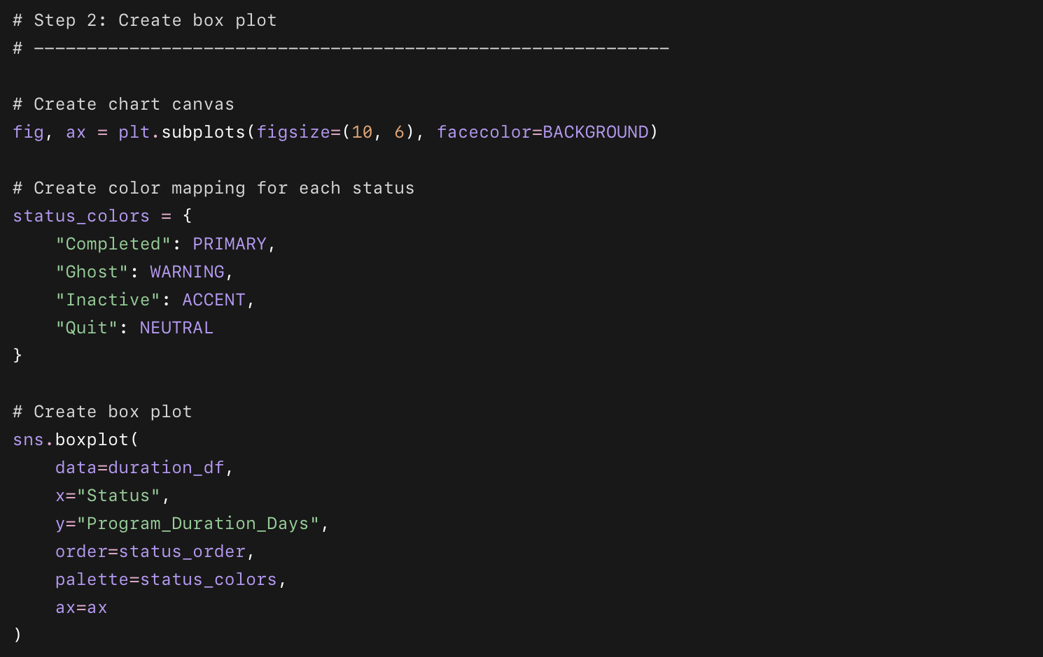
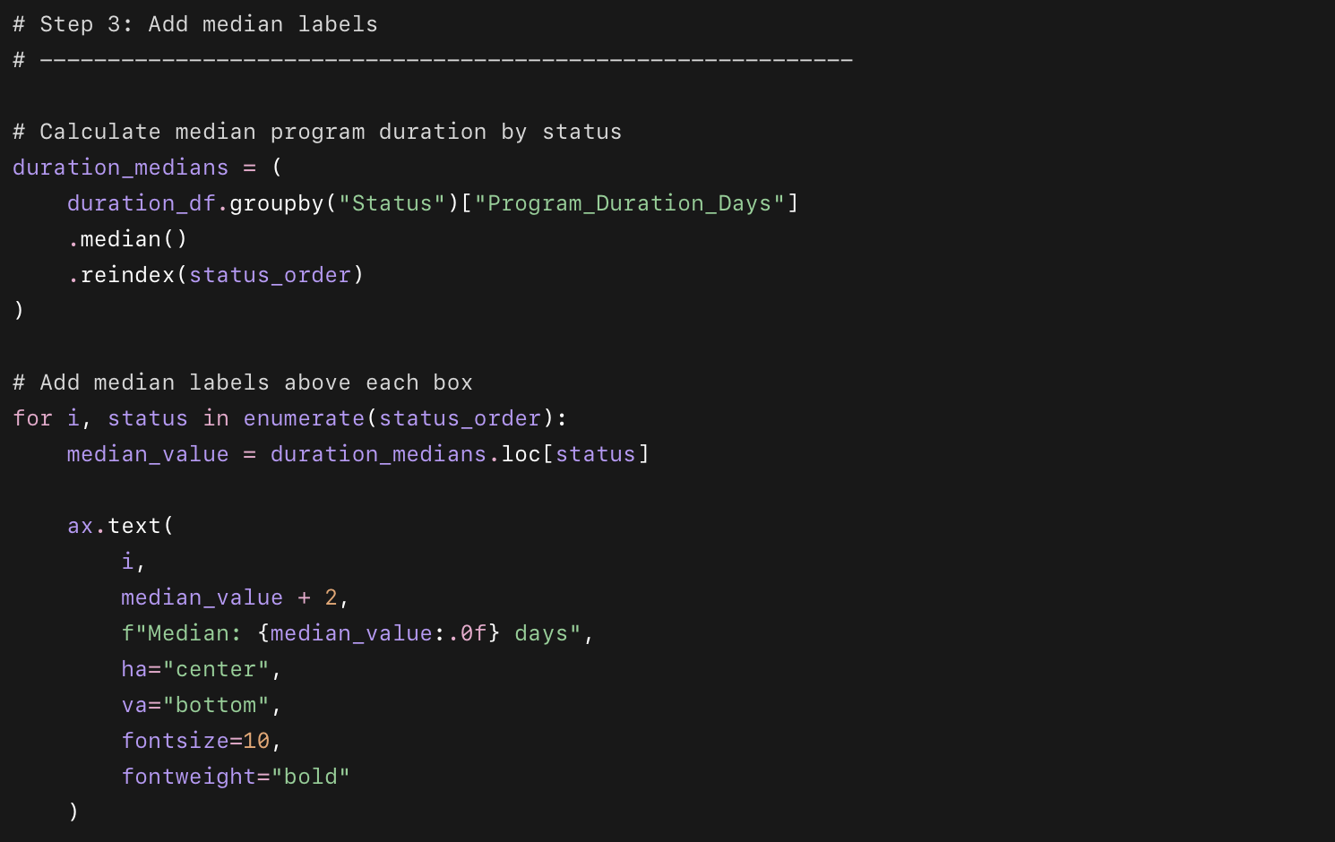
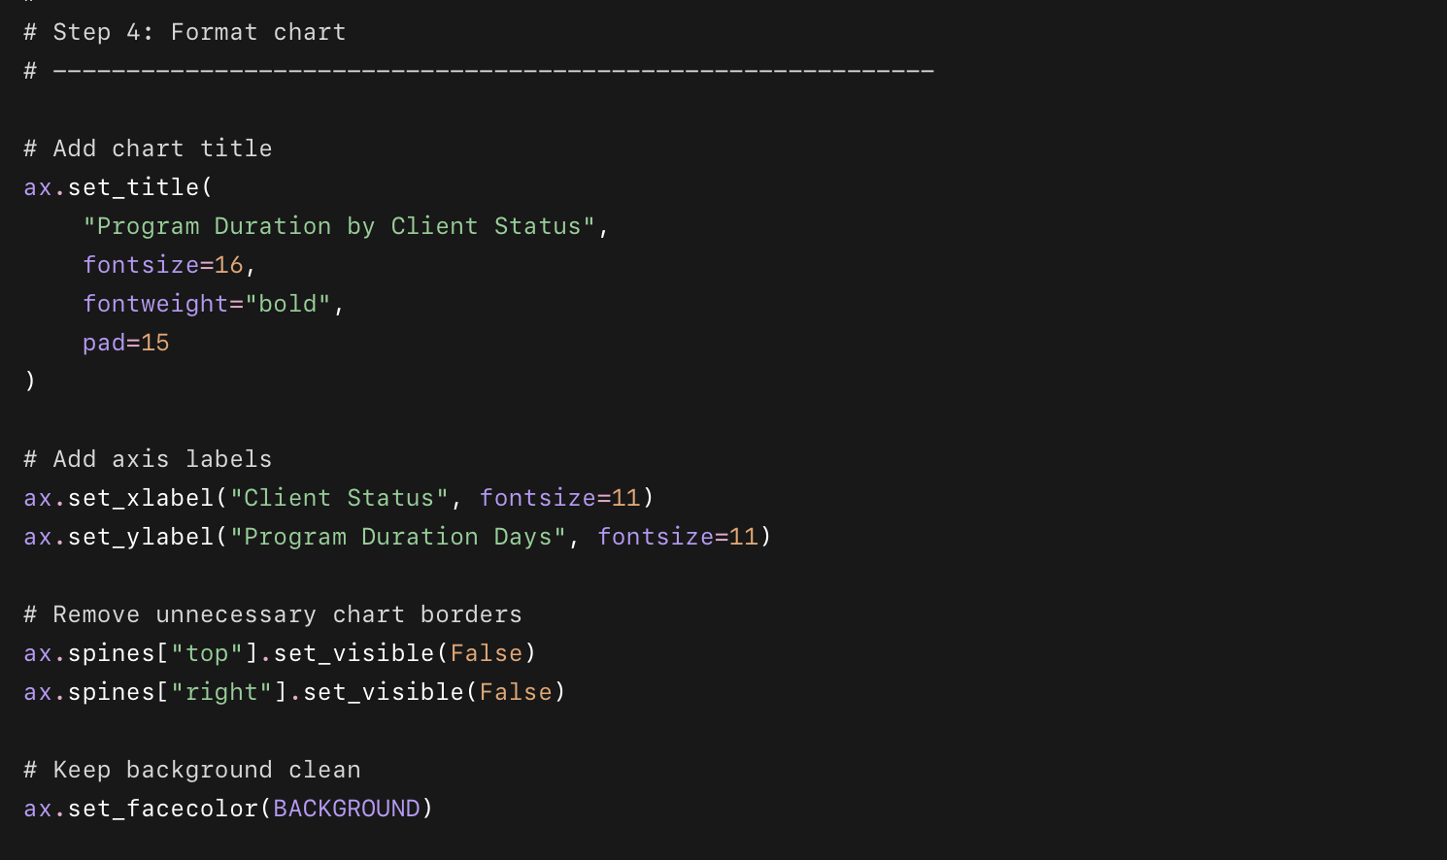
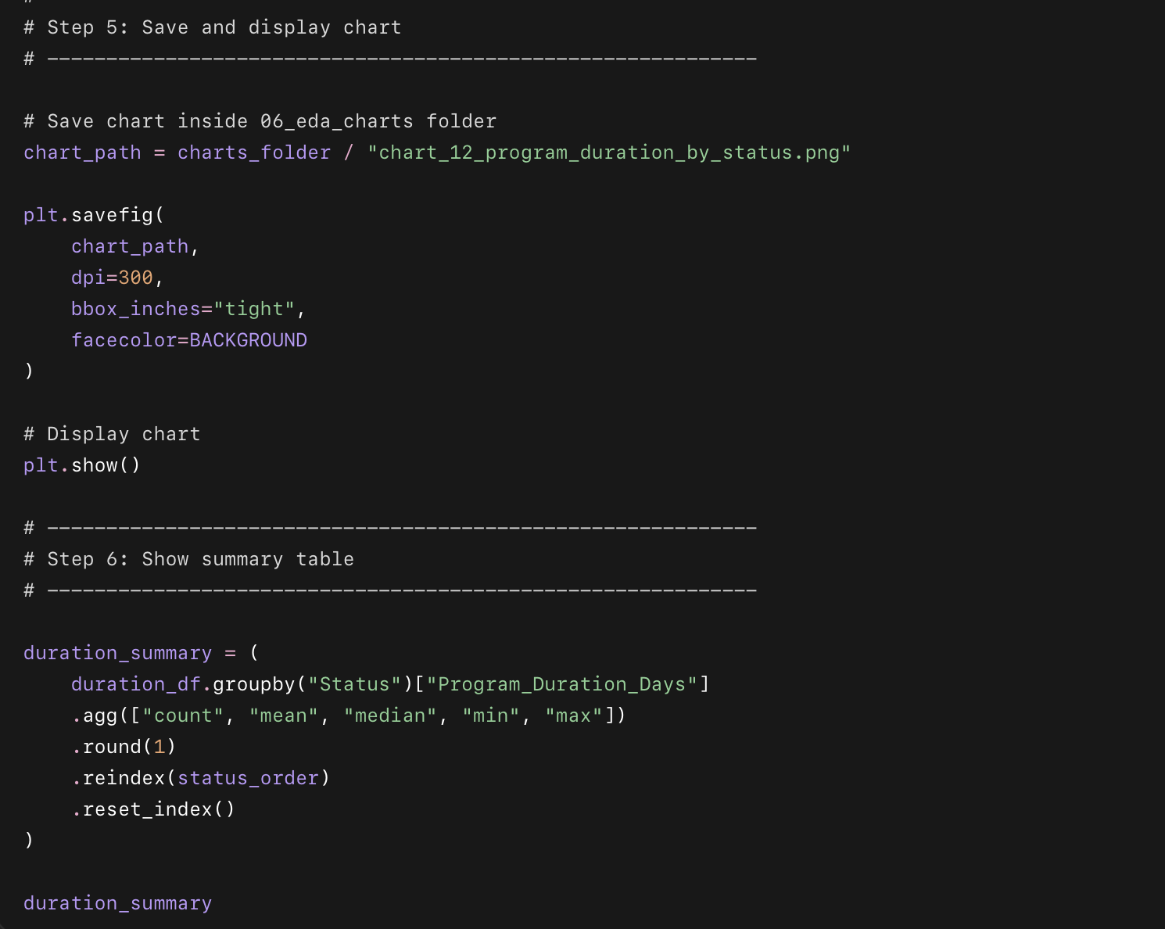

What this code does in short points
- Selects clients with status:
  - Completed
  - Ghost
  - Inactive
  - Quit
- Uses Program_Duration_Days to compare how long clients stayed in the program.
- Creates a box plot for each client status.
- Shows the median duration for each status.
- Helps identify whether dropouts leave early or stay for a while before becoming inactive.
- Saves the chart inside:
06_eda_charts/chart_12_program_duration_by_status.png

What question this chart answers
How does program duration differ between completed, ghost, inactive, and quit clients?

